Task on Jenkins -04
1) Setup Jenkins CICD pipeline using freestyle job using Docker containers using below code.
Source Code: https://github.com/betawins/hiring-app.git
Stages:
- Git Clone
- SonarQube Integration
- Maven Compilation
- Nexus Artifactory
- Slack Notification
- Deploy On tomcat
step-1
First we need to install ec2 instance with c7i.xlarge* (4 vCPU, 8 GB RAM) because
8 GB RAM comfortably runs all containers (Jenkins + SonarQube + PostgreSQL + Nexus) without OOM crashes.
- 4 vCPU handles concurrent builds, analysis, and uploads.
- Cost-effective for learning or small team.
- c7i.large (4 GB) works but can OOM during heavy SonarQube scans or Nexus indexing.
Launch EC2 Instance
- **AMI**: Amazon Linux 2023
- **Type**: c7i.xlarge
- **Storage**: 100 GB gp3
- **Security Group**: Open inbound:
- TCP 8080 (Jenkins)
- TCP 9000 (SonarQube)
- TCP 8081 (Nexus)
- TCP 22 (SSH) from your IP
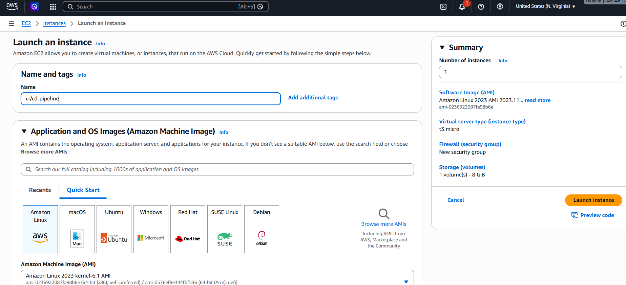
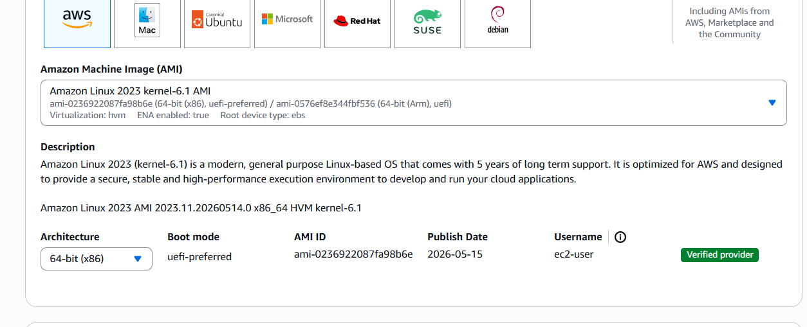
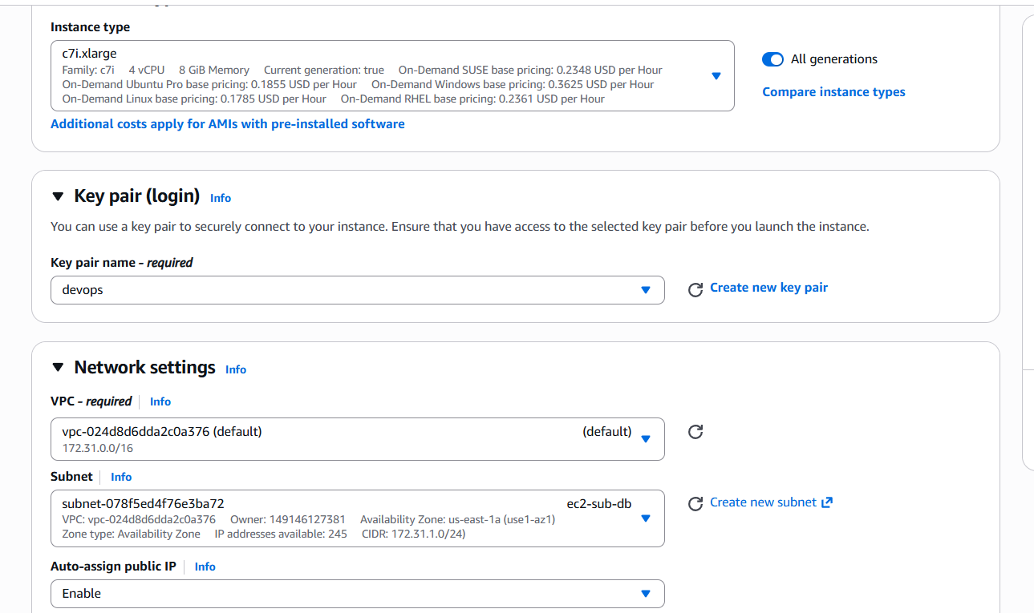
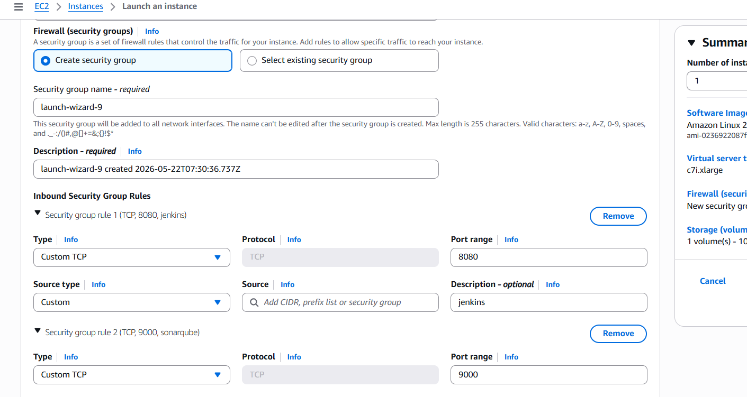
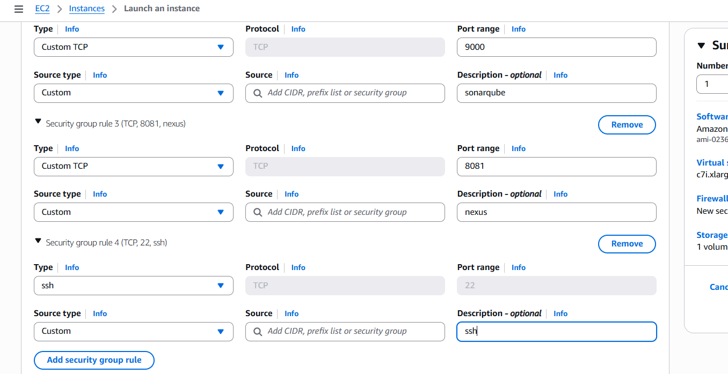
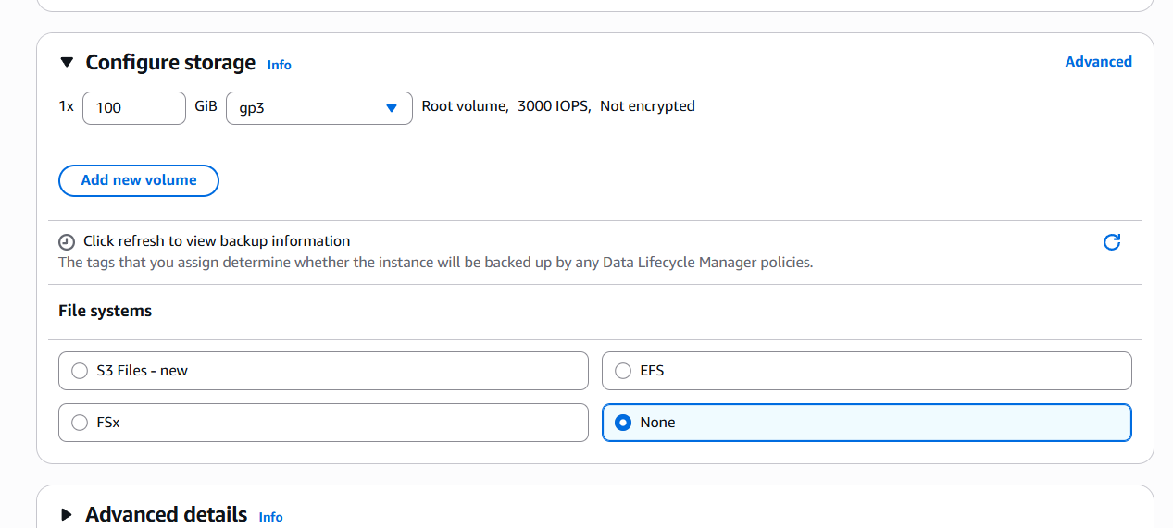
Successfully created a ec2 instance
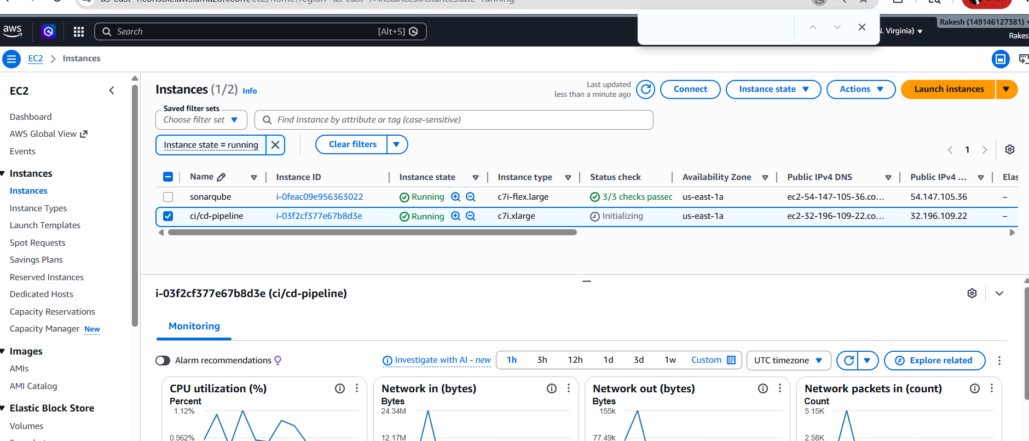
Step-2
- Install Docker & Docker Compose
Now connect to ec2 instance and install docker & docker Compose
- sudo yum update -y
- sudo yum install docker -y
- sudo systemctl start docker
- sudo systemctl enable docker
- sudo usermod -aG docker ec2-user
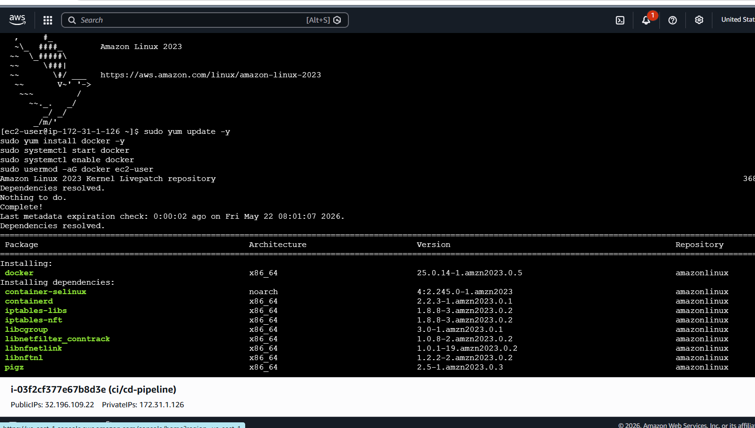
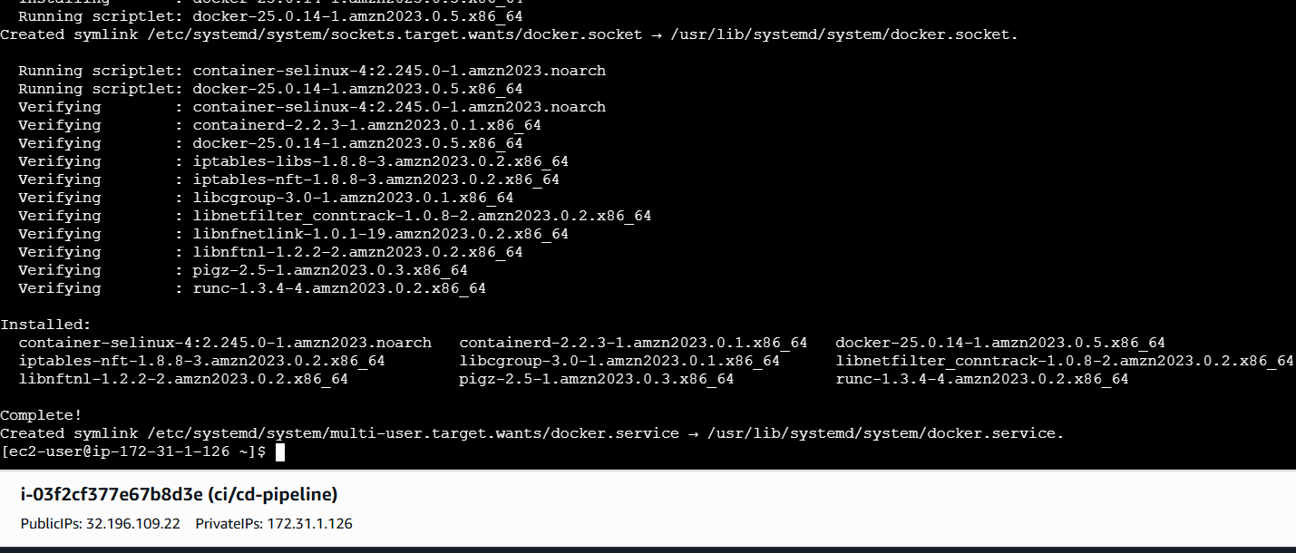
Install Docker Compose (v2+ plugin)
sudo curl -L "https://github.com/docker/compose/releases/latest/download/docker-compose-linux-x86_64" -o /usr/local/bin/docker-compose
sudo chmod +x /usr/local/bin/docker-compose
docker-compose –version
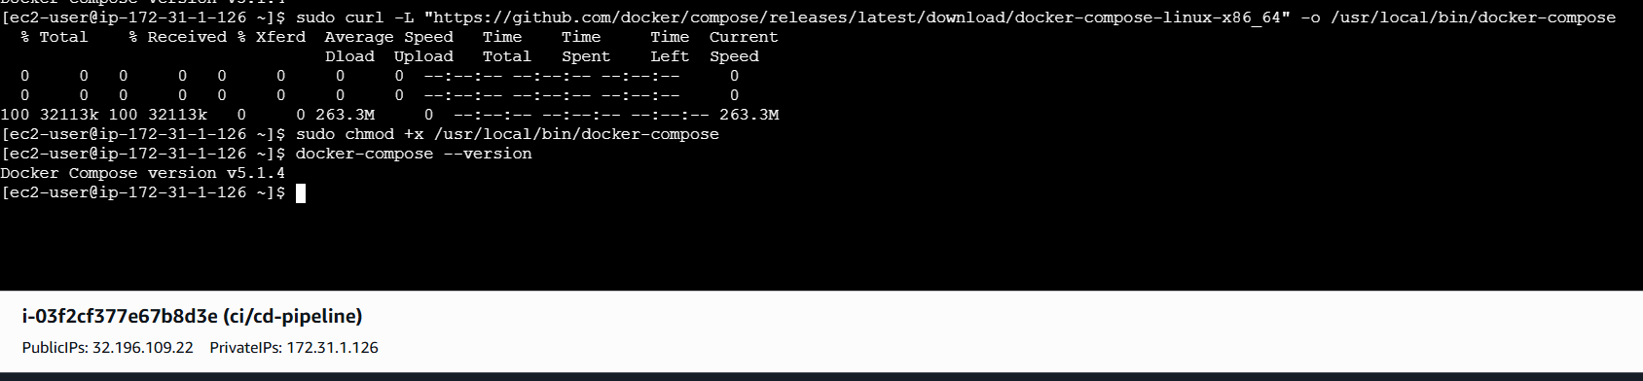

Re-login or run `newgrp docker` to apply group.
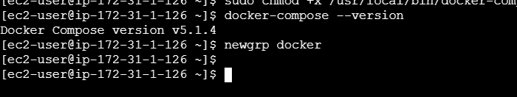

Step -3
Create docker-compose.yml

mkdir ~/docker-jenkins-stack && cd ~/docker-jenkins-stack
vi docker-compose.yml

Paste this **complete, tested docker-compose** (all tools with persistence):

```yaml
version: '3.8'

services:
jenkins:
image: jenkins/jenkins:lts-jdk21
container_name: jenkins
restart: always
ports:
- "8080:8080"
- "50000:50000"
volumes:
- jenkins_home:/var/jenkins_home
- /var/run/docker.sock:/var/run/docker.sock # For Docker-in-Docker
environment:
- JAVA_OPTS=-Djenkins.install.runSetupWizard=false

sonarqube:
image: sonarqube:community
container_name: sonarqube
restart: always
ports:
- "9000:9000"
volumes:
- sonarqube_data:/opt/sonarqube/data
- sonarqube_logs:/opt/sonarqube/logs
- sonarqube_extensions:/opt/sonarqube/extensions
environment:
- SONAR_JDBC_URL=jdbc:postgresql://postgres:5432/sonarqube
- SONAR_JDBC_USERNAME=sonar
- SONAR_JDBC_PASSWORD=sonar
- SONAR_ES_BOOTSTRAP_CHECKS_DISABLE=true # Disable bootstrap checks (helps on low RAM)
- SONAR_WEB_JAVAOPTS=-Xmx512m -Xms512m # Force low heap
- SONAR_CE_JAVAOPTS=-Xmx512m -Xms512m # Compute Engine low heap
mem_limit: 2g # Limit container to 2 GB (prevents OOM kill)

postgres:
image: postgres:15
container_name: postgres
restart: always
environment:
POSTGRES_USER: sonar
POSTGRES_PASSWORD: sonar
POSTGRES_DB: sonarqube
volumes:
- postgres_data:/var/lib/postgresql/data

nexus:
image: sonatype/nexus3:latest
container_name: nexus
restart: always
ports:
- "8081:8081"
volumes:
- nexus_data:/nexus-data

tomcat:
image: tomcat:10.1-jdk21
container_name: tomcat
restart: always
ports:
- "8082:8080" # Maps host 8082 to container 8080 (avoids port conflicts)
volumes:
- tomcat_data:/usr/local/tomcat/webapps # Persistent webapps directory
- tomcat_logs:/usr/local/tomcat/logs # Persistent logs
environment:
- JAVA_OPTS=-Xmx1024m -Xms512m -Djava.awt.headless=true # Conservative heap for Tomcat

volumes:
jenkins_home:
sonarqube_data:
sonarqube_logs:
sonarqube_extensions:
postgres_data:
nexus_data:
tomcat_data:
tomcat_logs:
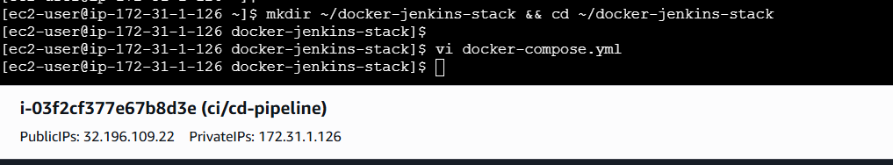

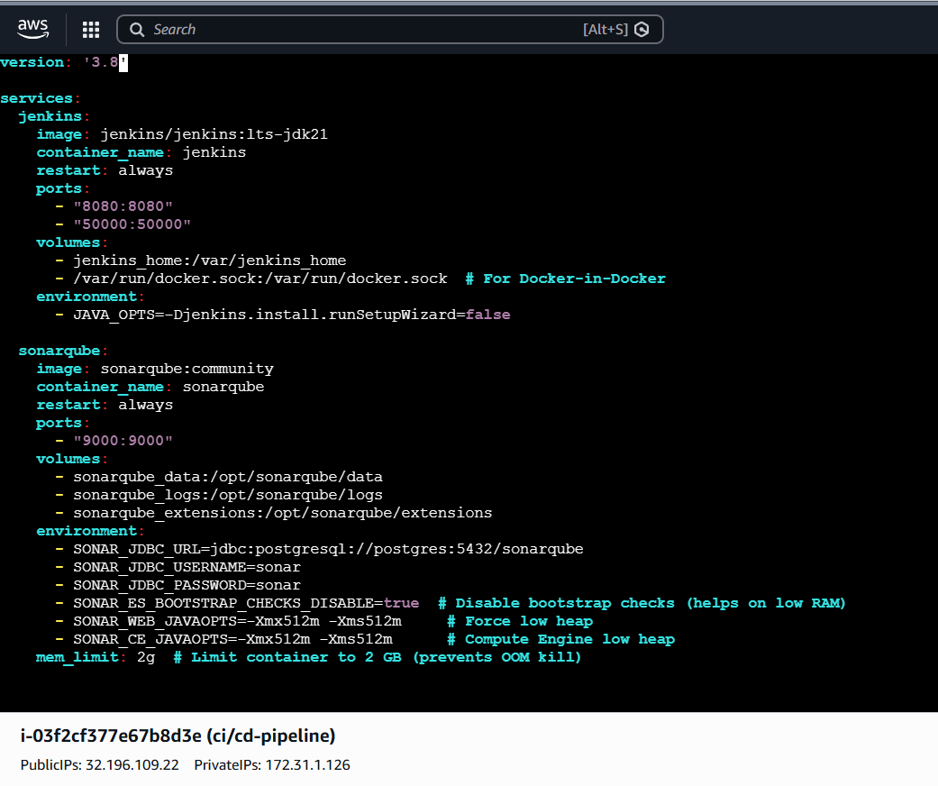
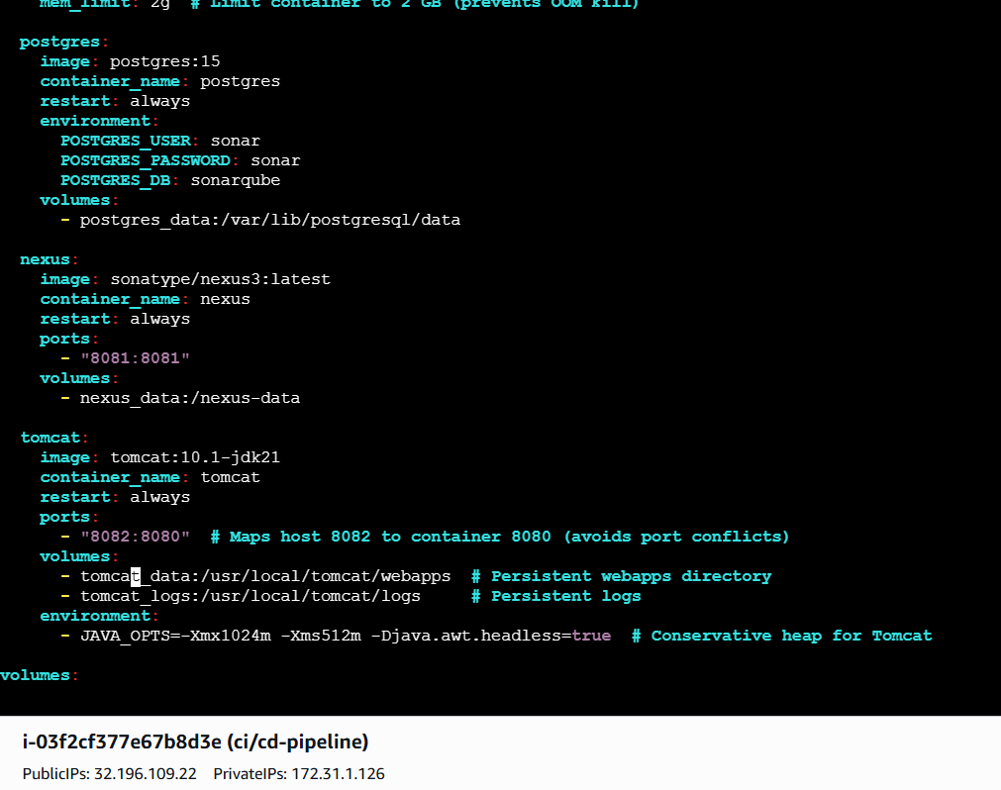
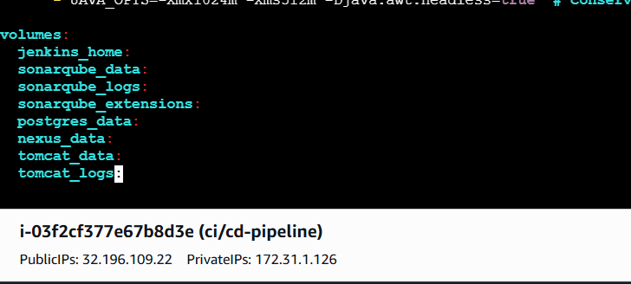
Step -04

Start All Services
docker-compose up -d
docker-compose ps # Check all containers are Up

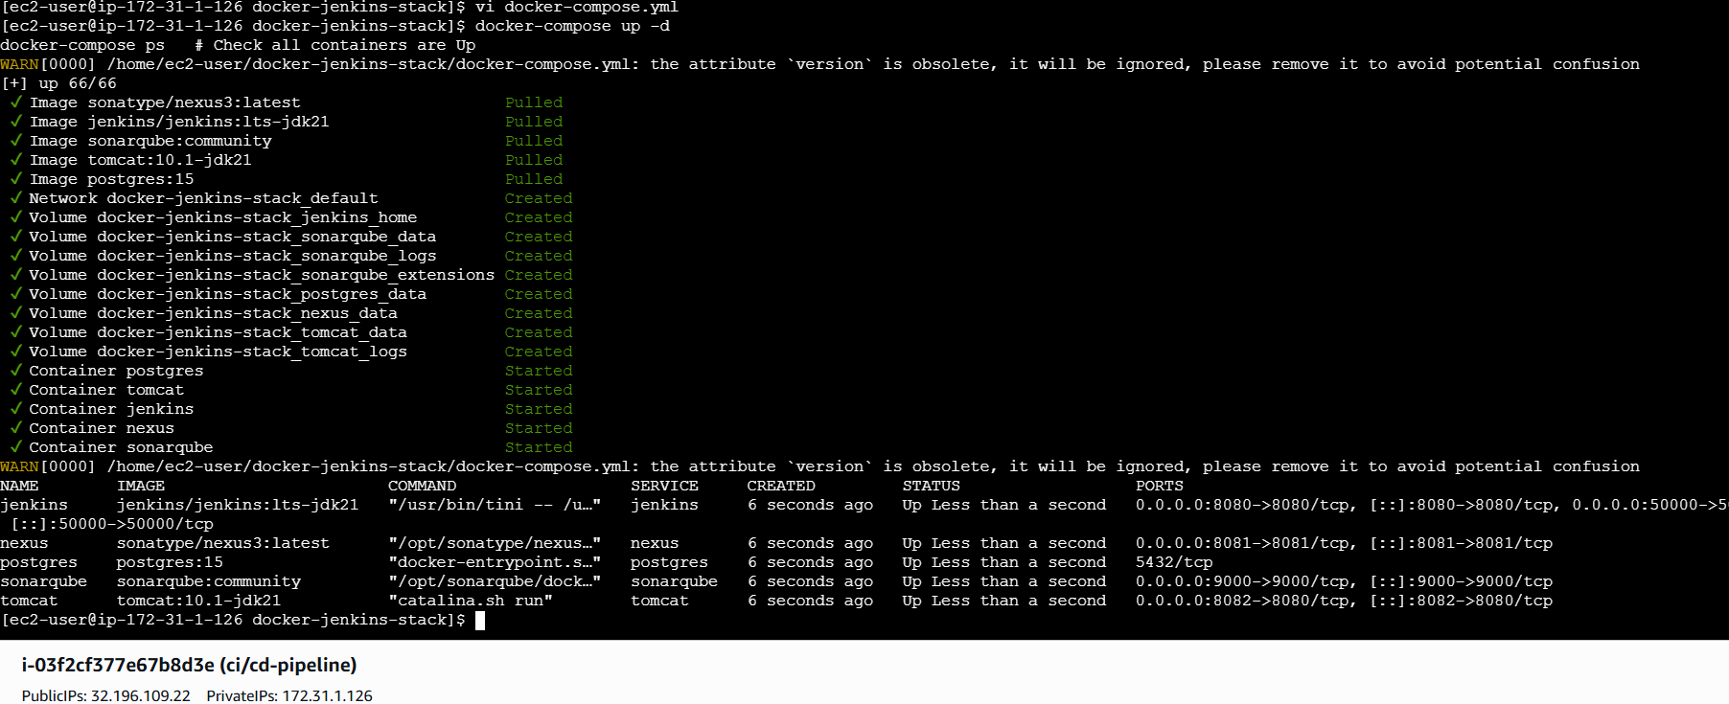
Step -5
Now we have to do Initial Setup
Open Jenkins in browser: `http://<your-ip>:8080
Look at the top-right corner:
- If it shows your username (e.g., `admin` or the name you set), you're already logged in → go to Step 2.
- If it asks for login → use the initial password from:
```bash
docker exec jenkins cat /var/jenkins_home/secrets/initialAdminPassword
```
(or `/var/lib/jenkins/secrets/initialAdminPassword` if non-Docker)
- Login → complete wizard → create first admin user.

Enable Security & User Management (If Not Already Done)

1. Go to **Manage Jenkins** (left sidebar) → **Configure Global Security**
2. Under **Security Realm**:
- Select **Jenkins' own user database**
- Check **Allow users to sign up** (optional — if you want self-registration)
- Uncheck **Anyone can do anything** (very important!)
- Save
-Under **Authorization**:
- Choose **Matrix-based security** (simple for small setups)
- Add your admin user (or group) with **full permissions** (Overall: Administer, etc.)
- Save

After saving → **Manage Users** now appears in the left menu.

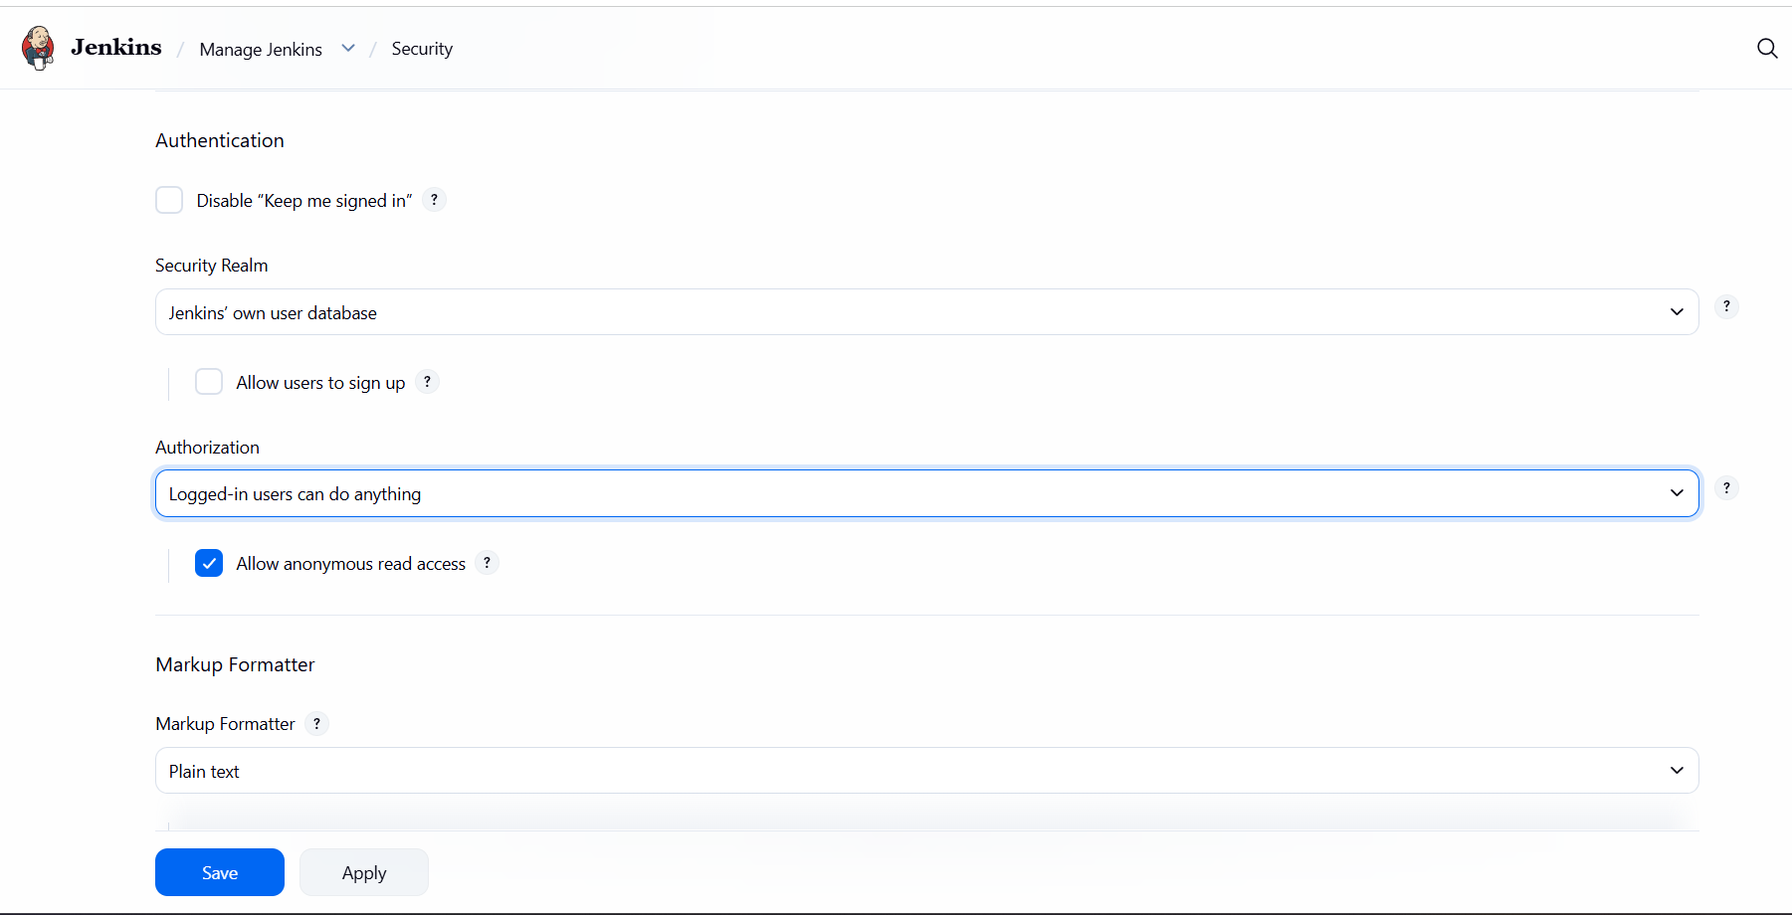

--Create New Users & Passwords

Now that security is enabled:

1. Go to **Manage Jenkins** → **Manage Users**
2. Click **Create User**
3. Fill in:
- **Username**: e.g., `devuser1`
- **Password**: Set a strong password
- **Confirm password**: Same
- **Full name** & **Email** (optional but recommended)
4. Click **Create**

Repeat for as many users as needed.
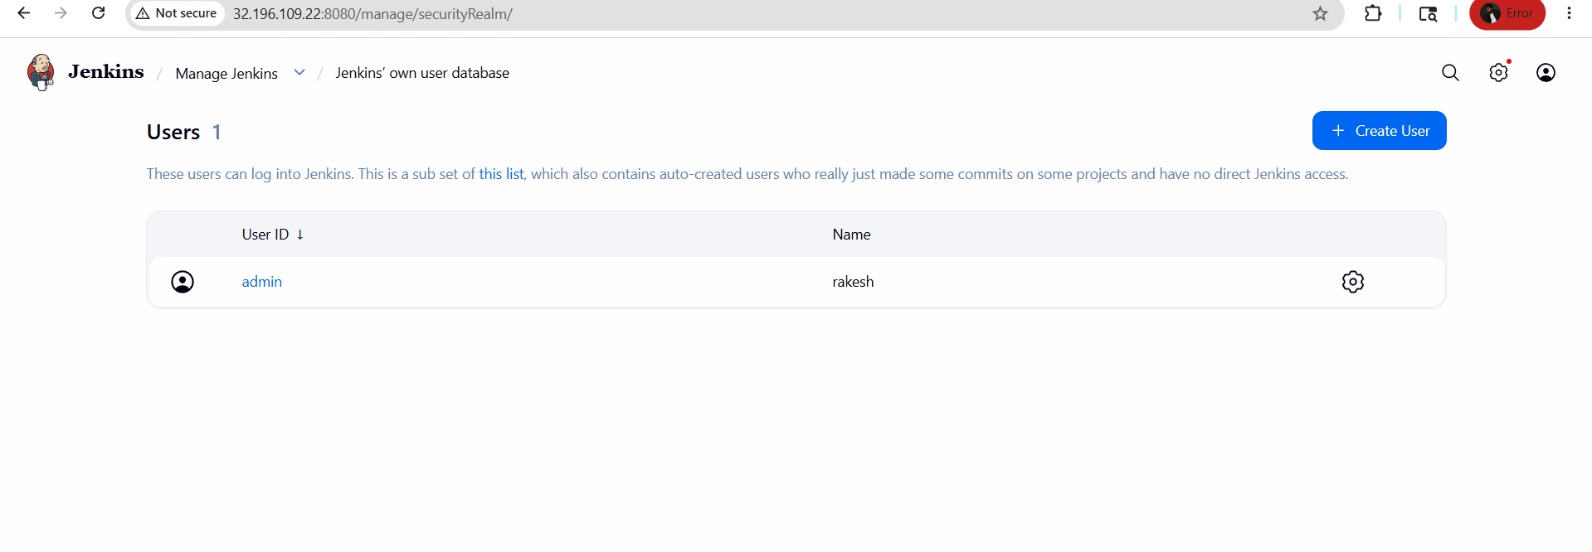
Assign Permissions to New Users

1. Back to **Manage Jenkins** → **Configure Global Security**
2. In the **Matrix-based security** table:
- Find the new user (or create a group like `developers`)
- Assign limited permissions, e.g.:
- Job: Build, Read, Cancel
- View: Read
- **Do NOT** give Overall: Administer to normal users
Test New Users

1. Log out (top-right)
2. Log in as the new user (e.g., `devuser1` / your password)
3. Confirm they have access only to allowed features

#### Optional: Enable Self-Signup (Users Create Their Own Accounts)

If you want anyone to sign up without admin help:

1. **Manage Jenkins** → **Configure Global Security**
2. Under **Security Realm** → Check **Allow users to sign up**
3. Save

Now the login page shows a **"Sign up"** link.
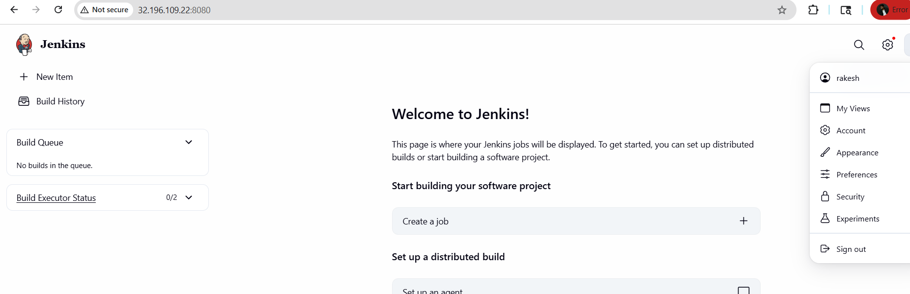
Now do this in sonarqube
SonarQube** (`http://<ec2-ip>:9000`):
- Login: `admin` / `admin` → change password
- Create project & token
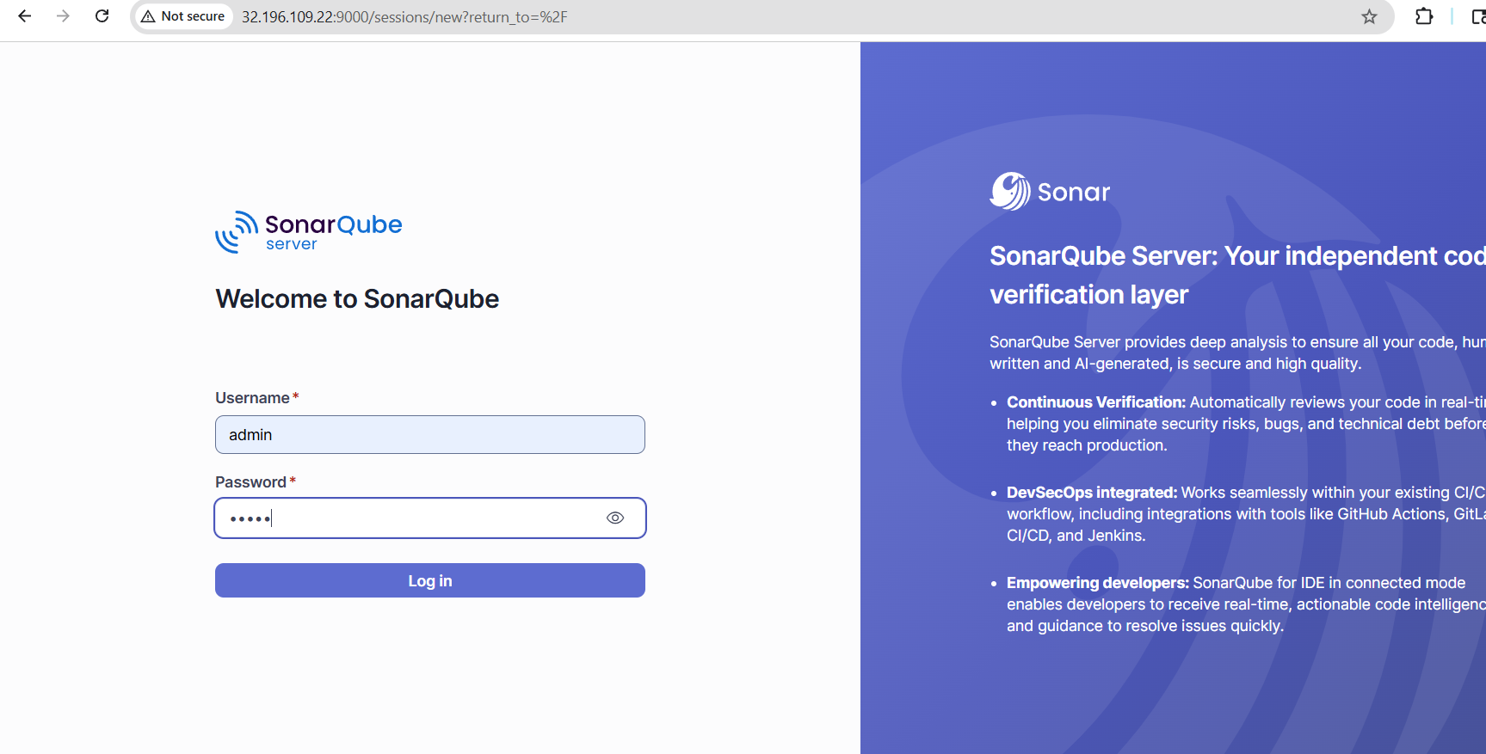
Changed password for soanrqube and login
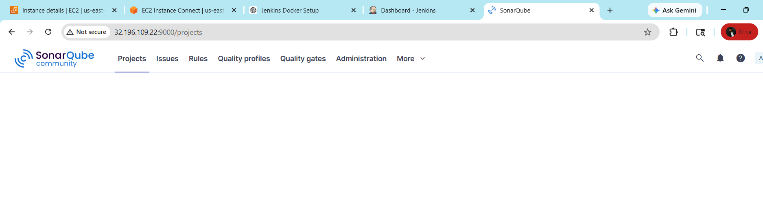
And do this for same to nexus
Nexus** (`http://<ec2-ip>:8081`):
- Unlock with: `docker exec nexus cat /nexus-data/admin.password`
- Enable anonymous access or create user

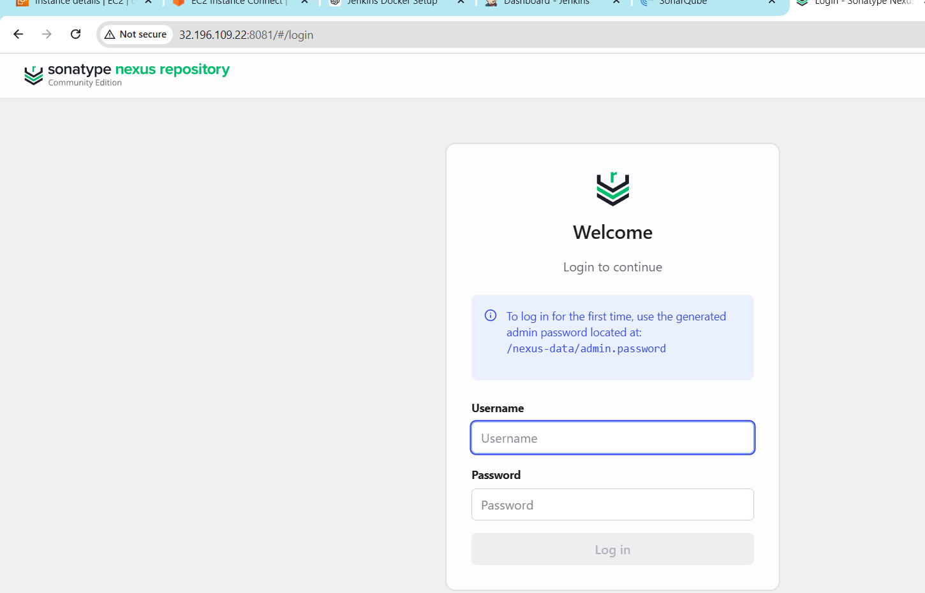
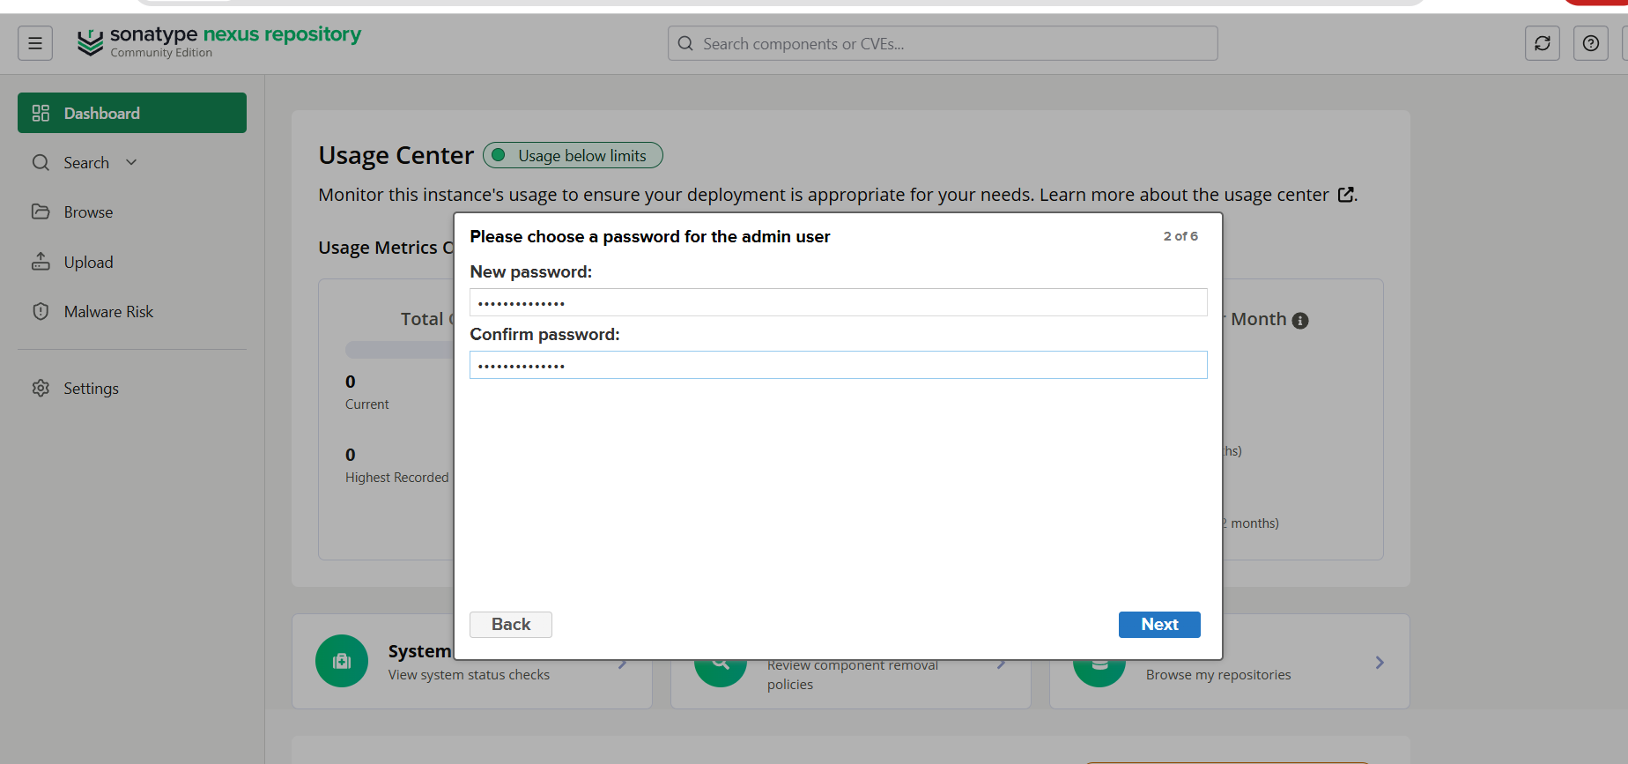
Changed password for nexus

--Enable anonymous access
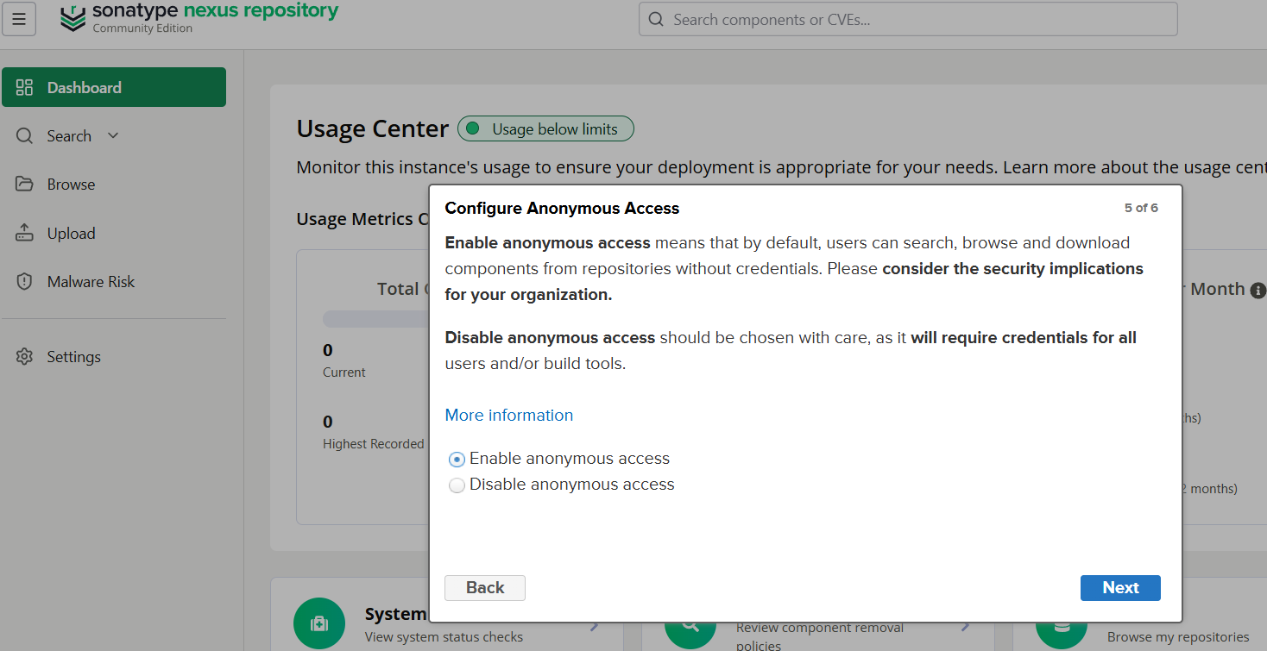

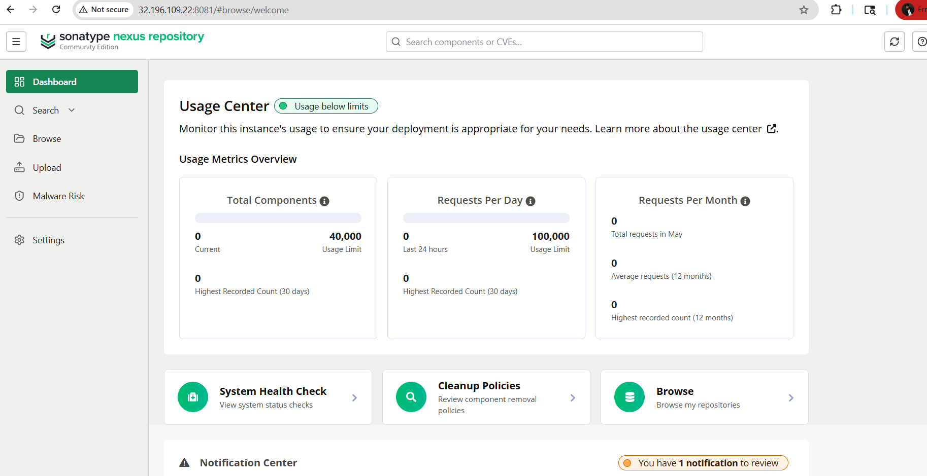

Step -6
SonarScanner & Maven (Inside Jenkins)

- In Jenkins UI → **Manage Jenkins → Tools**:
- Add **Maven** (install automatically)
- Add **SonarScanner** (install automatically)

Now your pipelines can use:
```groovy
tools {
maven 'Maven3'
}
withSonarQubeEnv('SonarQube') {
sh 'mvn sonar:sonar'
}
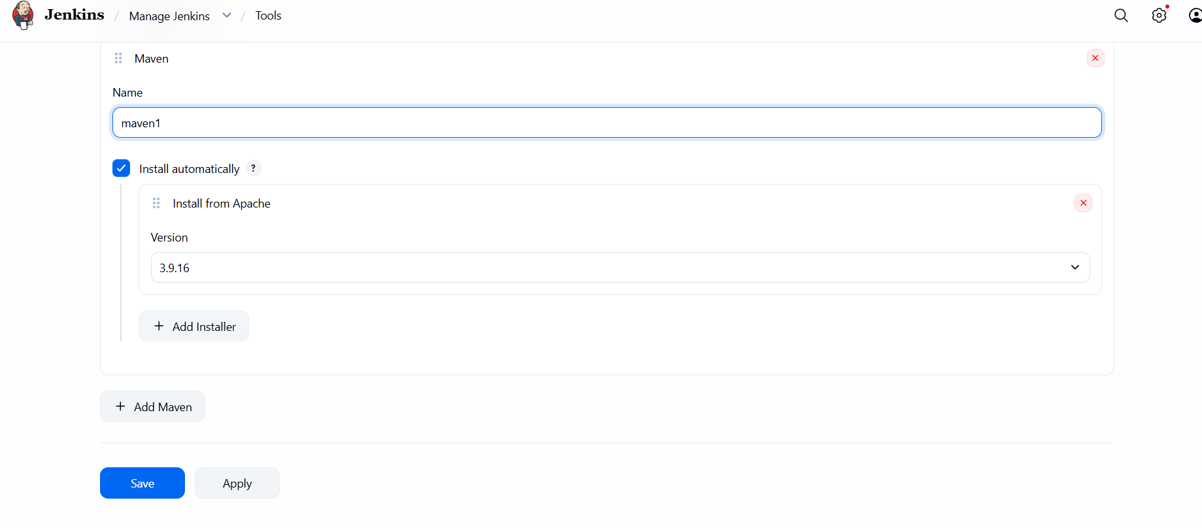

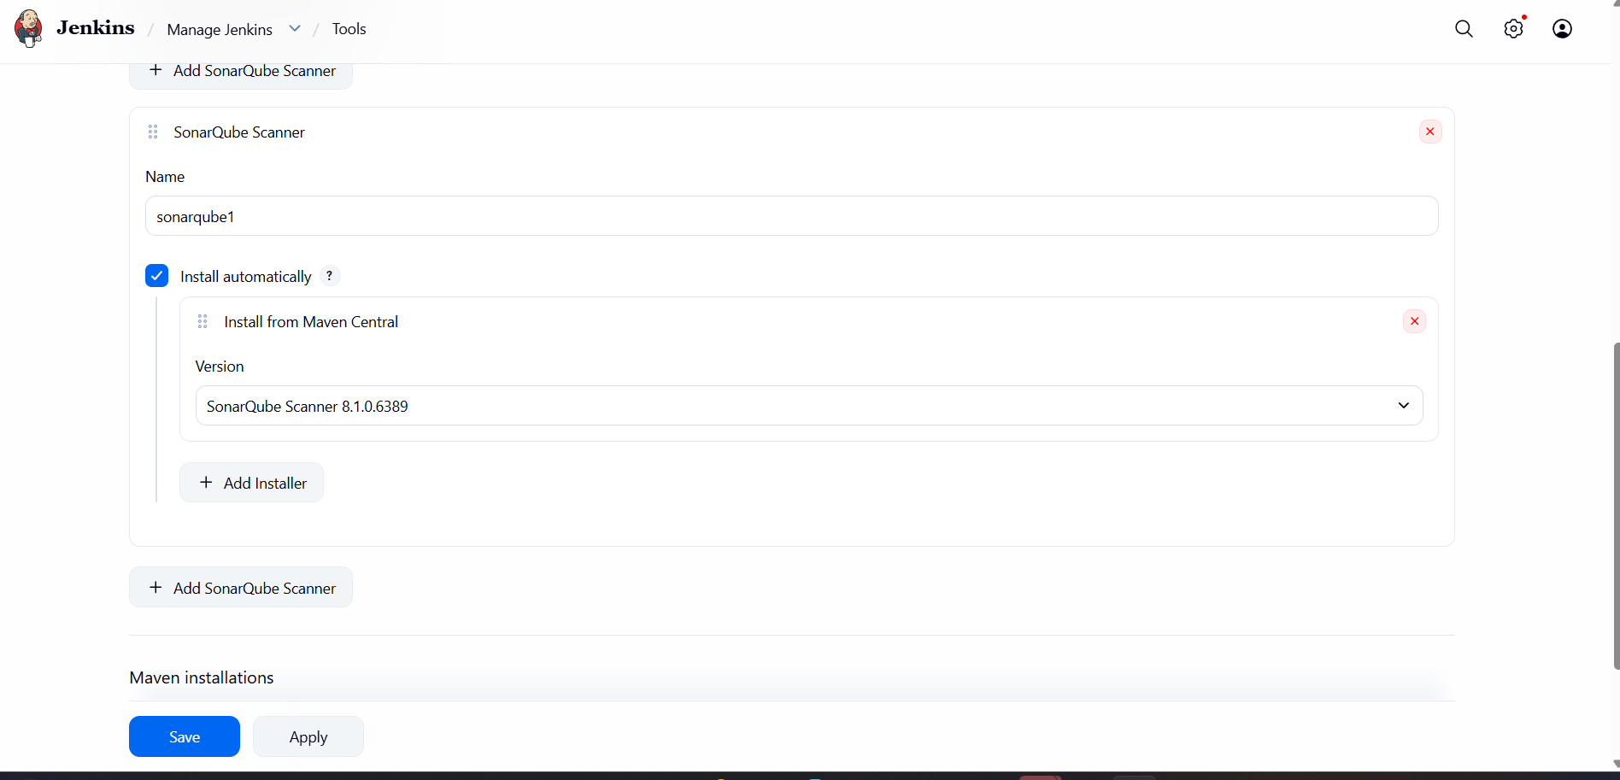

Now your pipelines can use:
```groovy
tools {
maven 'Maven3'
}
withSonarQubeEnv('SonarQube') {
sh 'mvn sonar:sonar'
}
```

To do the verification
```bash
docker-compose ps
curl http://localhost:8080

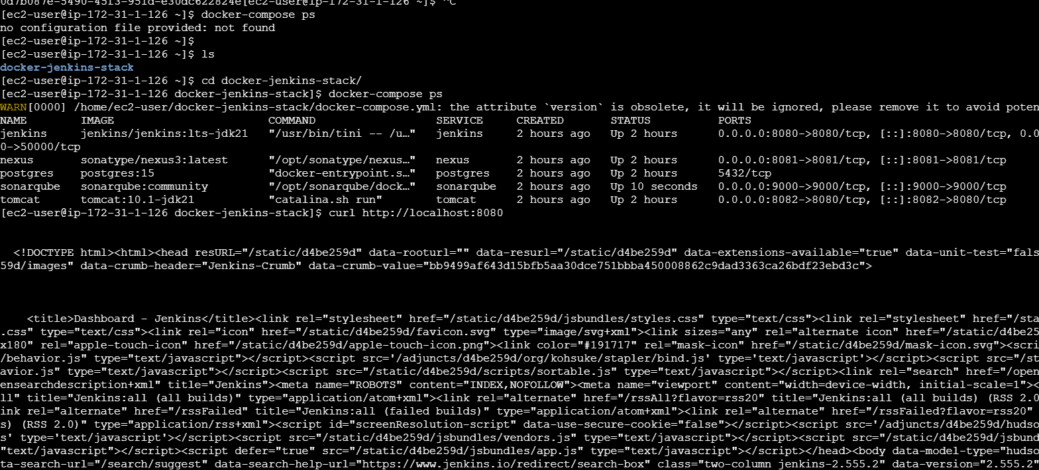
curl http://localhost:9000
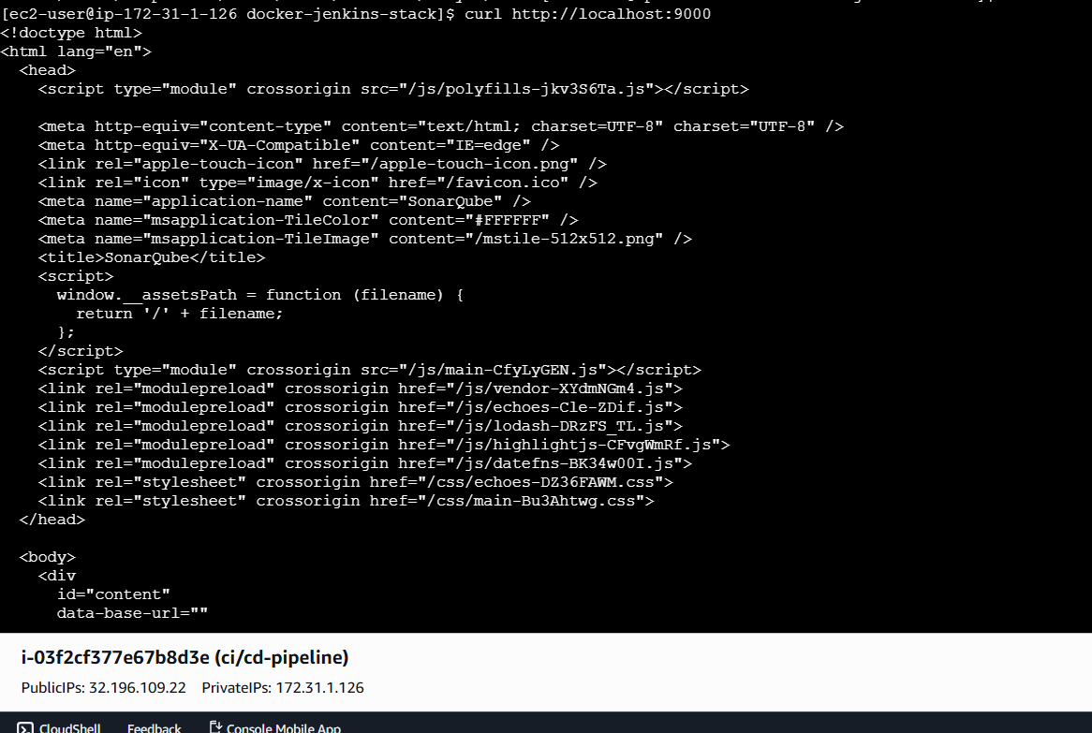
curl http://localhost:8081
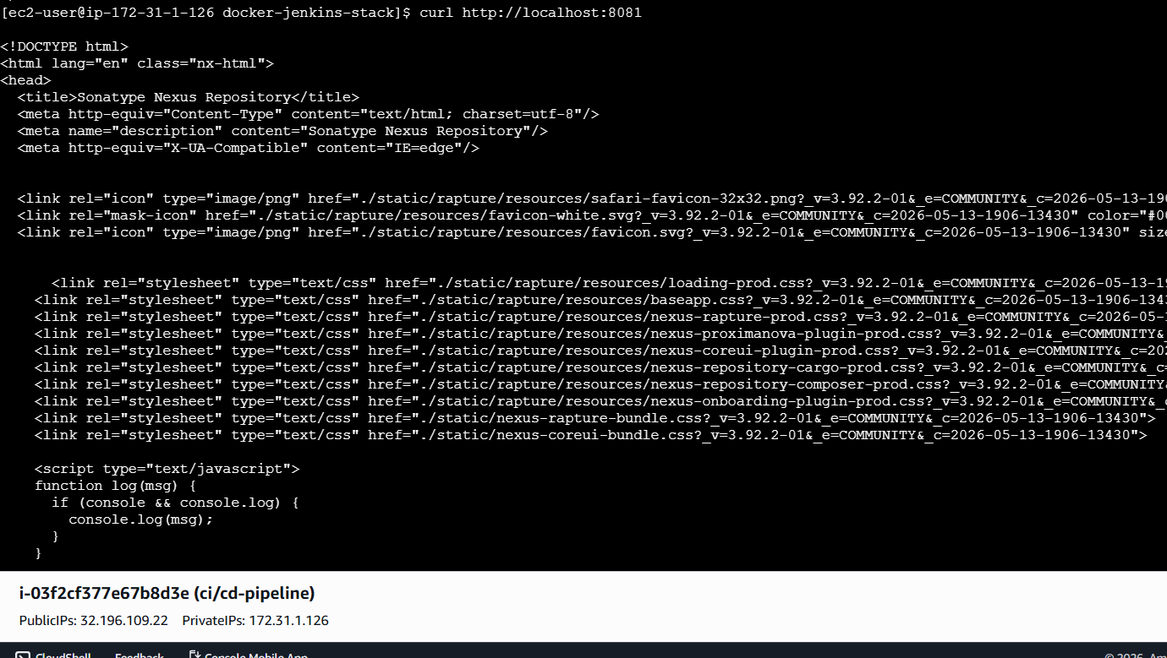
curl http://localhost:8082

```
Step -7
Install Tools Manually Inside the Jenkins Container (Quick & Direct)

1. Access the running Jenkins container:
```bash
docker exec -it jenkins bash
```

2. Inside the container, install everything:
--now switch to root user updateand install git

```bash
# Update package list
apt update

# Install Git (very important for cloning repos)
apt install git -y
git --version # Should show git 2.x
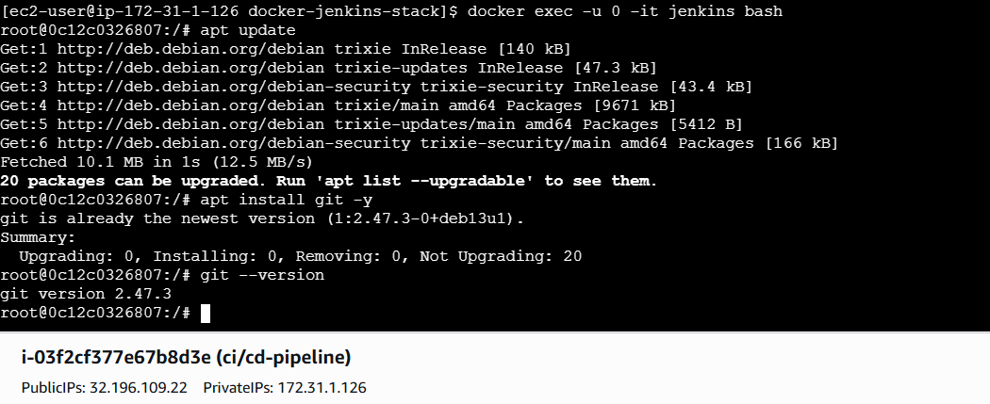

# Install Maven (latest version)
wget https://downloads.apache.org/maven/maven-3/3.9.9/binaries/apache-maven-3.9.9-bin.tar.gz
tar -xzf apache-maven-*.tar.gz
mv apache-maven-* /opt/maven
ln -s /opt/maven/bin/mvn /usr/local/bin/mvn
mvn -version # Should show Maven 3.9.9 with Java 21
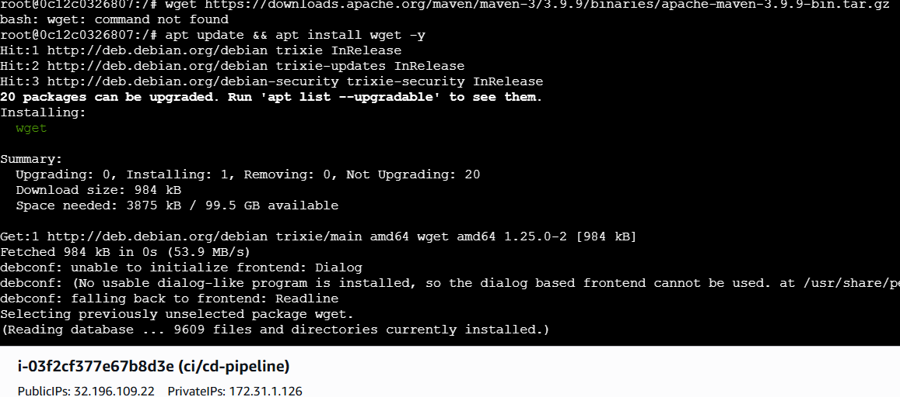
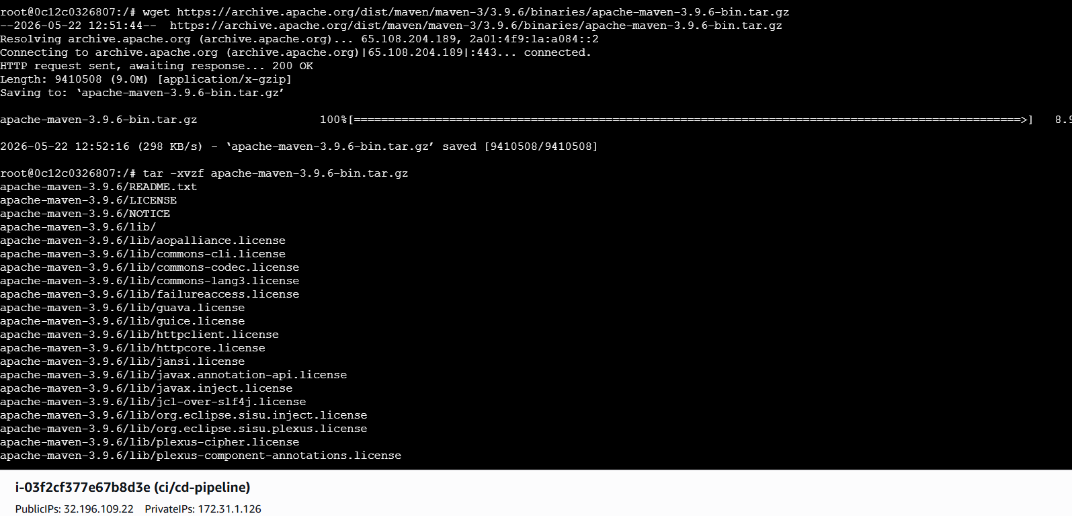
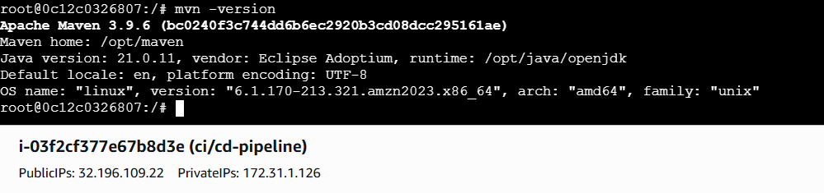

# Install SonarScanner (latest CLI)
wget https://binaries.sonarsource.com/Distribution/sonar-scanner-cli/sonar-scanner-cli-6.1.0.4477-linux.zip
unzip sonar-scanner-cli-*.zip
mv sonar-scanner-* /opt/sonar-scanner
ln -s /opt/sonar-scanner/bin/sonar-scanner /usr/local/bin/sonar-scanner
sonar-scanner --version
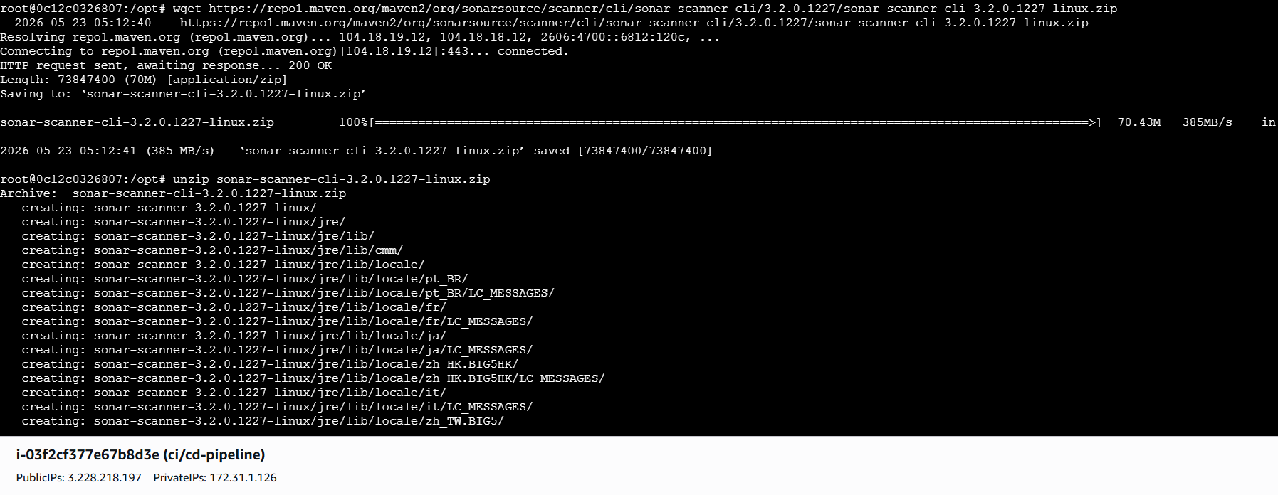
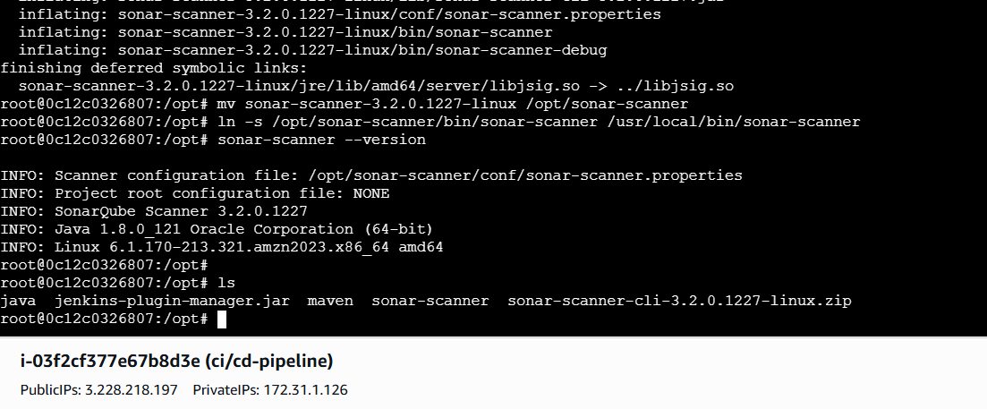

```

3. Exit container:
```bash
exit
```

Now your pipeline can use `mvn`, `git`, and `sonar-scanner` directly — no changes needed in Jenkins UI.
Now **Access Tomcat**:
- URL: `http://<your-ec2-public-ip>:8082`
- Default Tomcat manager: `http://<your-ec2-public-ip>:8082/manager/html`
- Username: `admin` (you need to set it up first — see below)

**Set Up Tomcat Admin (One-Time)**:
Edit Tomcat users file:
```bash
docker exec -it tomcat bash
vi /usr/local/tomcat/conf/tomcat-users.xml
```

Step 1: Start Tomcat Container
SSH into tomcat-server and run:
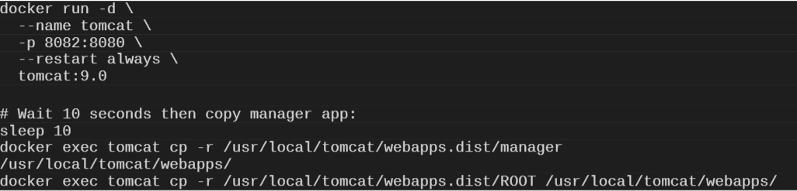
Step 2: Configure Tomcat Users
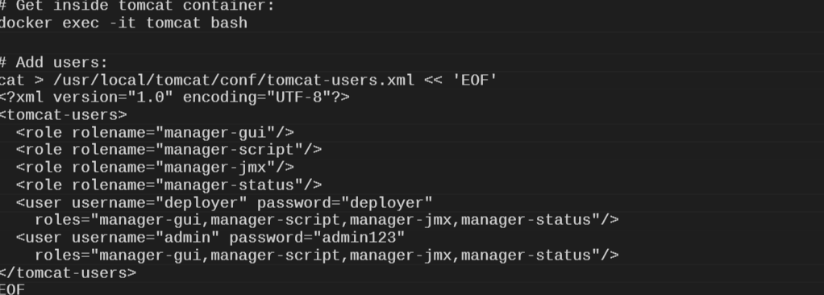
Step 3: Fix 403 Access Denied Error
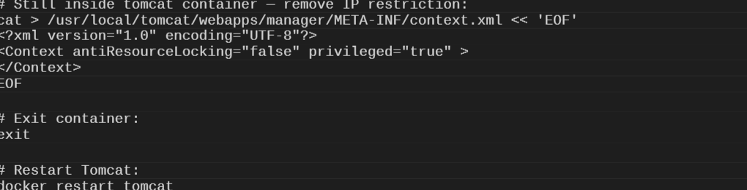
Verify: Open http://<tomcat-IP>:8082/manager/html
Login: deployer / deployer — You should see the Tomcat Manager page.

Step 4: Add Tomcat Credentials in Jenkins
Go to Jenkins → Manage Jenkins → Credentials → Global → Add Credentials
Kind: Username with password
Username: deployer
Password: deployer
ID: tomcat-creds
Click Create
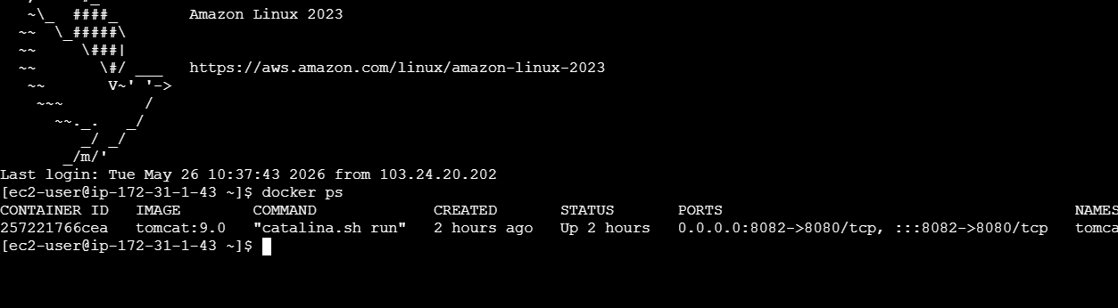

Add inside `<tomcat-users>` tag (before `</tomcat-users>`)
Get inside tomcat container:
docker exec -it tomcat bash
# Add users:
cat > /usr/local/tomcat/conf/tomcat-users.xml << 'EOF'
<?xml version="1.0" encoding="UTF-8"?>
<tomcat-users>
<role rolename="manager-gui"/>
<role rolename="manager-script"/>
<role rolename="manager-jmx"/>
<role rolename="manager-status"/>
<user username="deployer" password="deployer"
roles="manager-gui,manager-script,manager-jmx,manager-status"/>
<user username="admin" password="admin123"
roles="manager-gui,manager-script,manager-jmx,manager-status"/>
</tomcat-users>

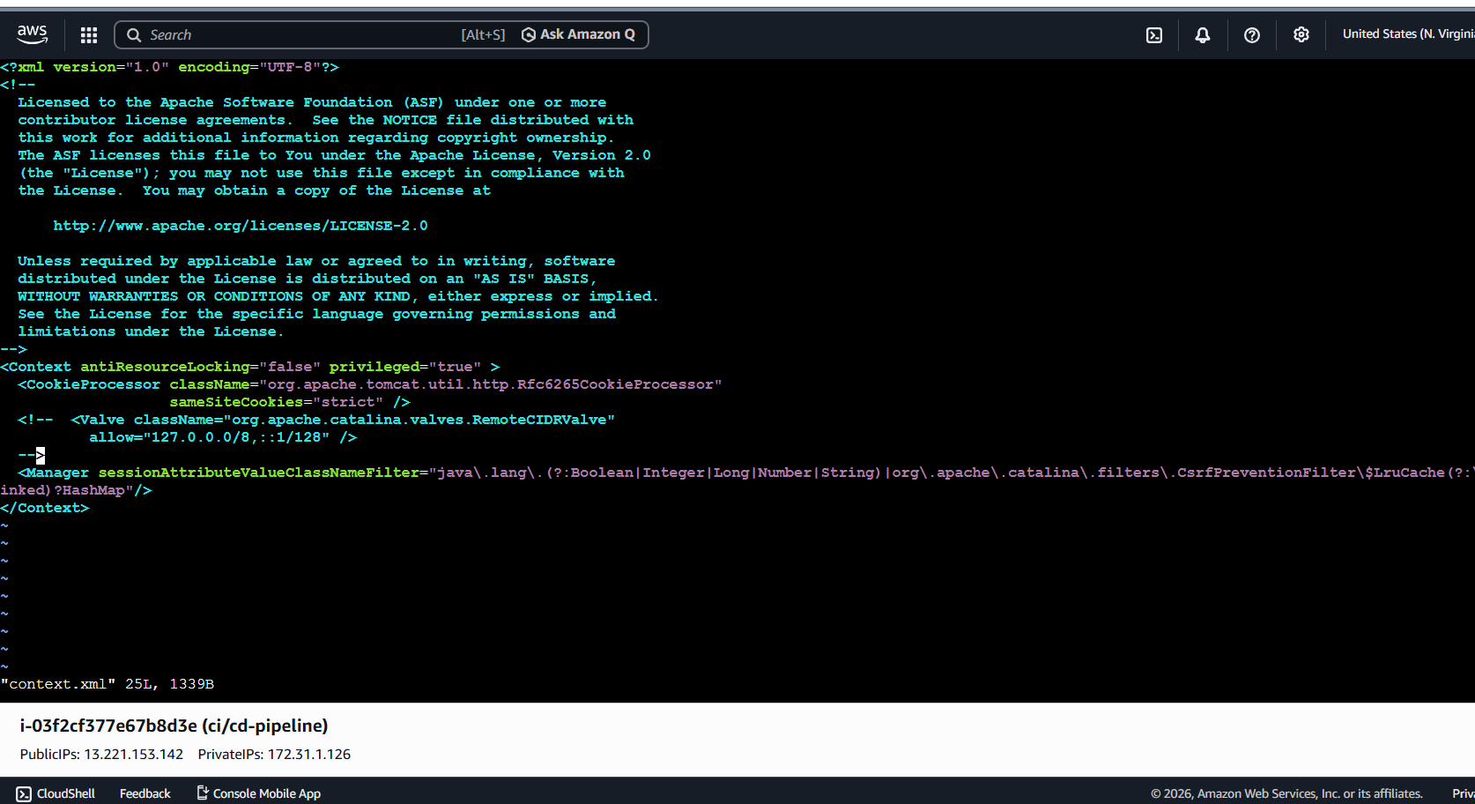
Save → restart Tomcat:
```bash
exit
docker restart tomcat

Now log in to Tomcat manager with:
- Username: deployer
- Password: deployer

**Deploy Apps to Tomcat**:
- Drop your `.war` files into `/opt/tomcat/webapps` on the host (maps to container `/usr/local/tomcat/webapps`):
```bash
sudo cp your-app.war /opt/tomcat/webapps/

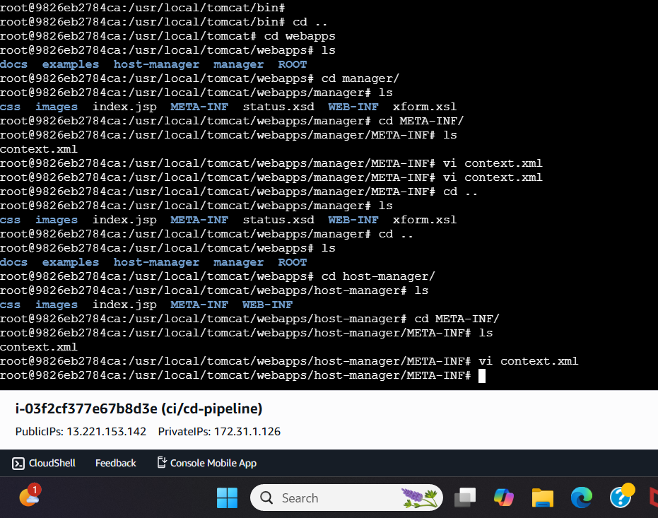
Now add all credentials in Jenkins tomcat,sonar and nexus

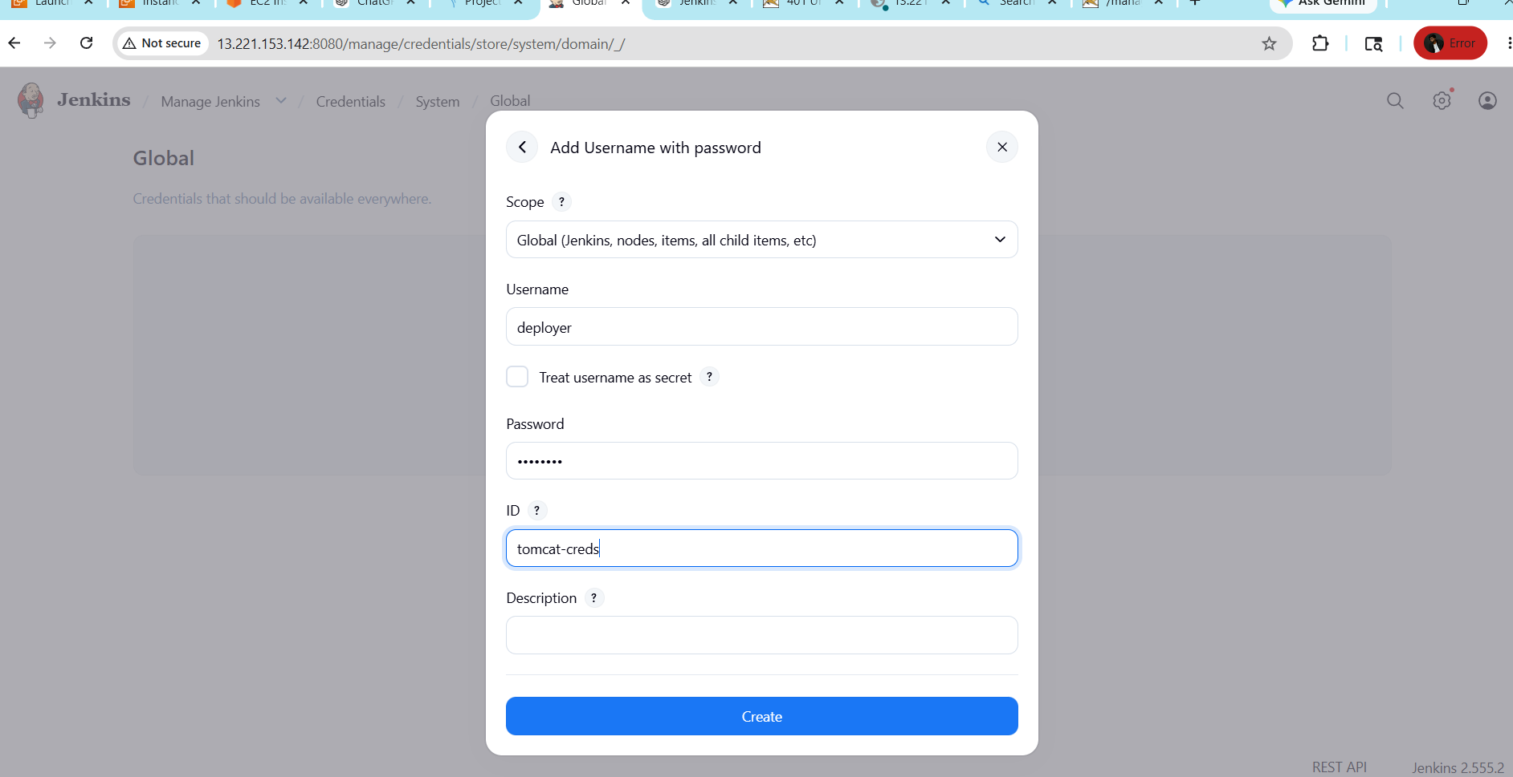
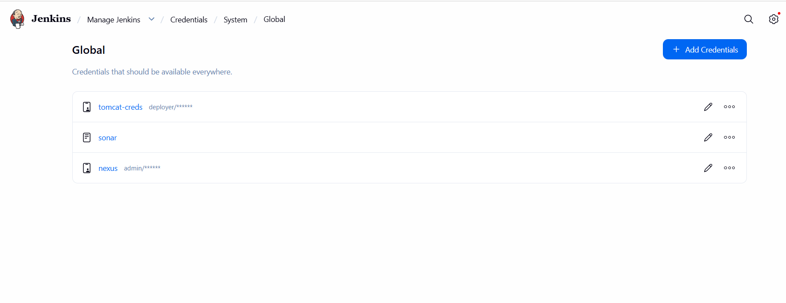
And also give sonarqube and maven path in jenkins
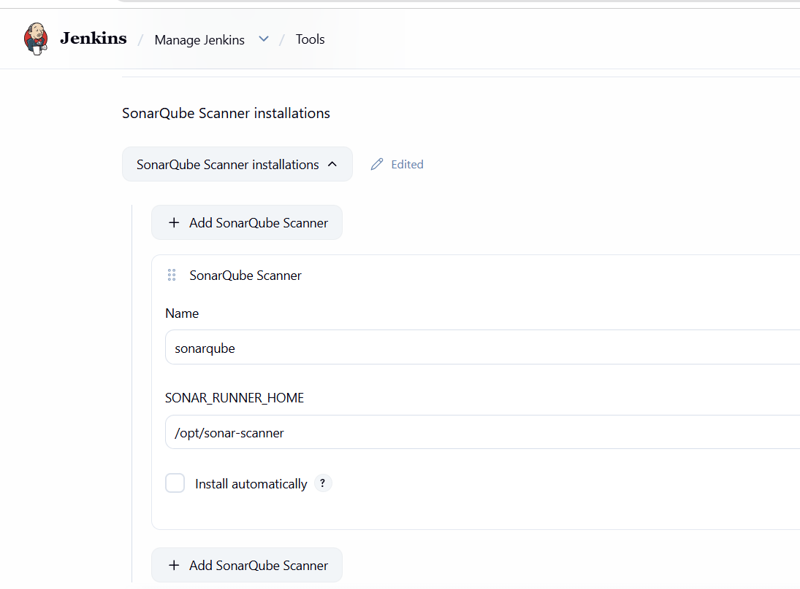
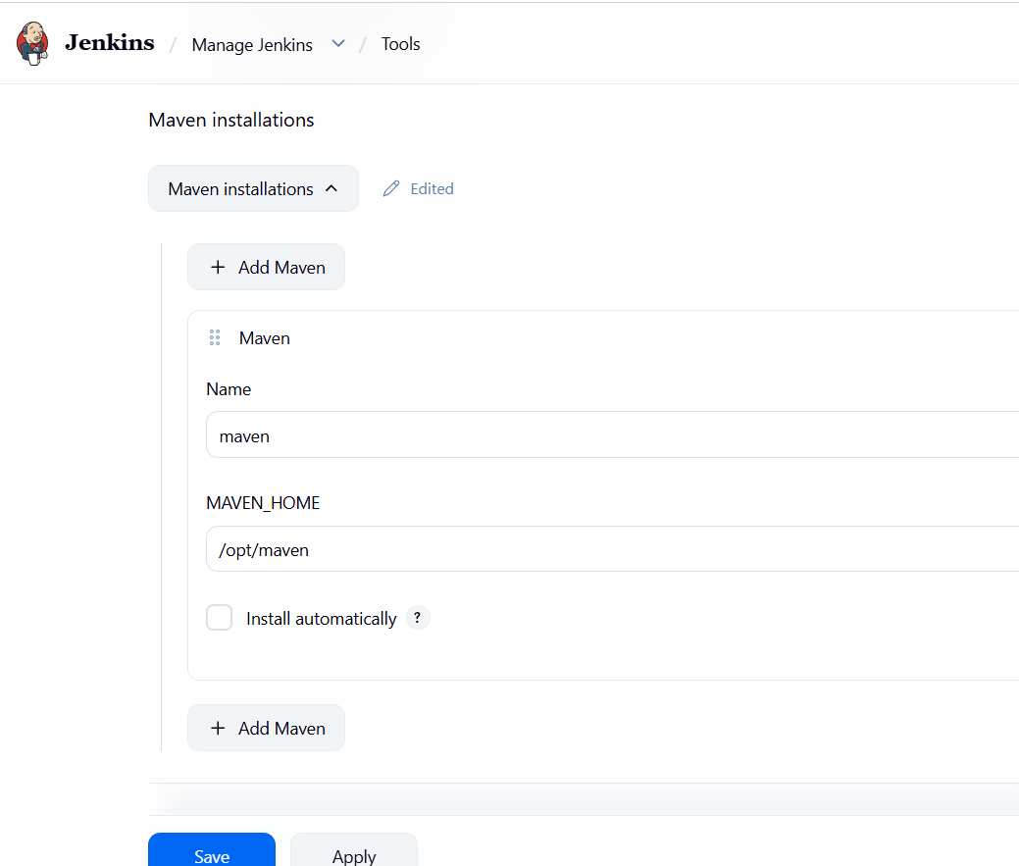
Create Freestyle Job
Source: https://github.com/betawins/hiring-app.git | Branch: main
Create the Job
Jenkins New Item→
Name: declarative
Select: Freestyle project
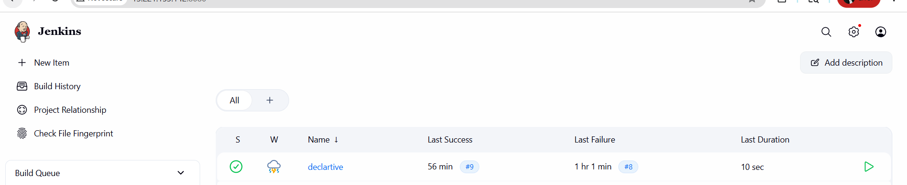
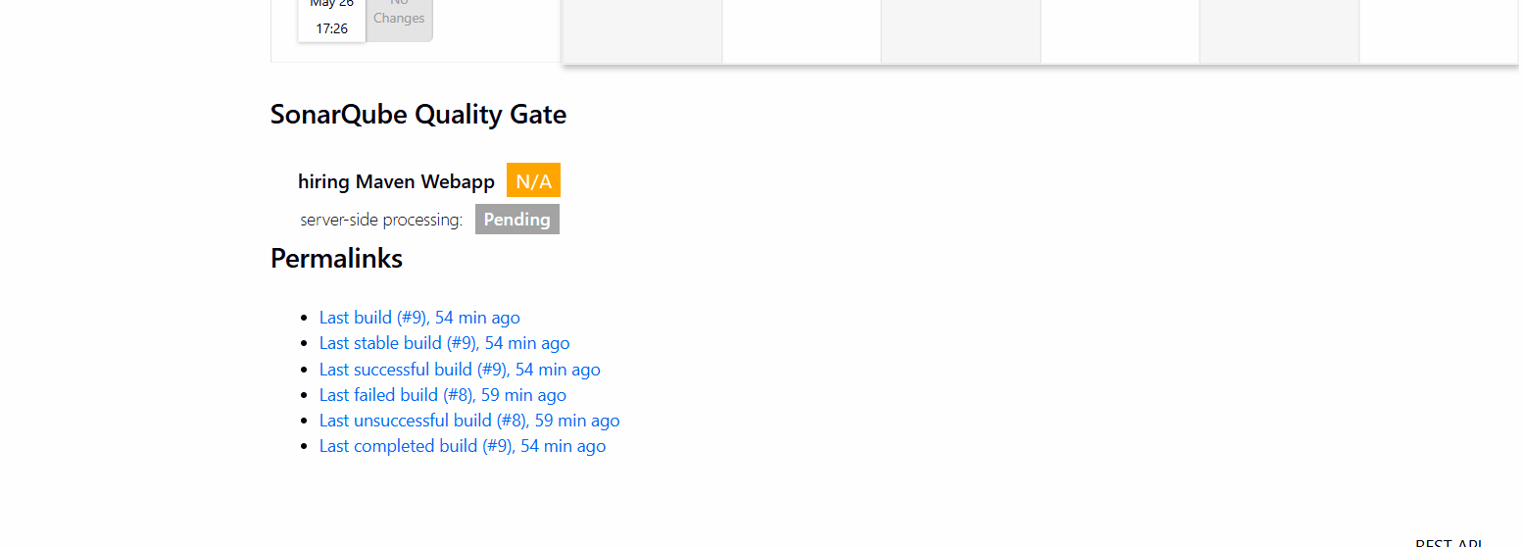
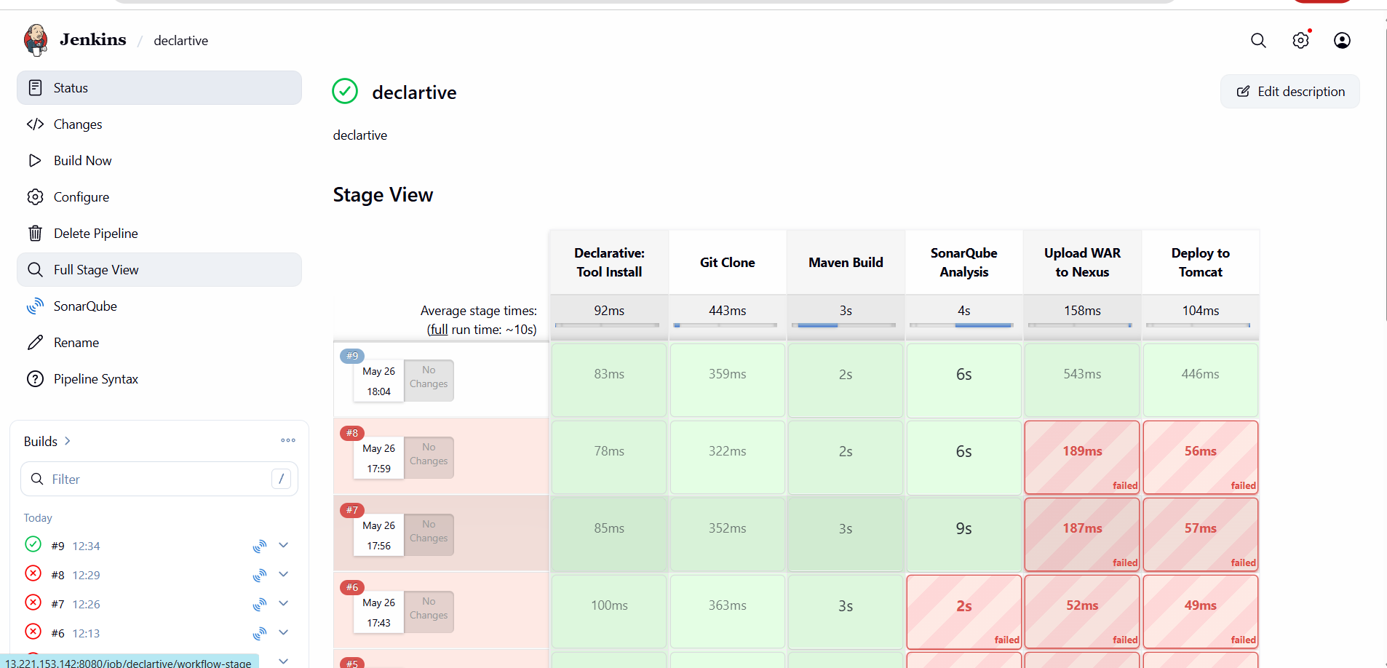
Now we can see
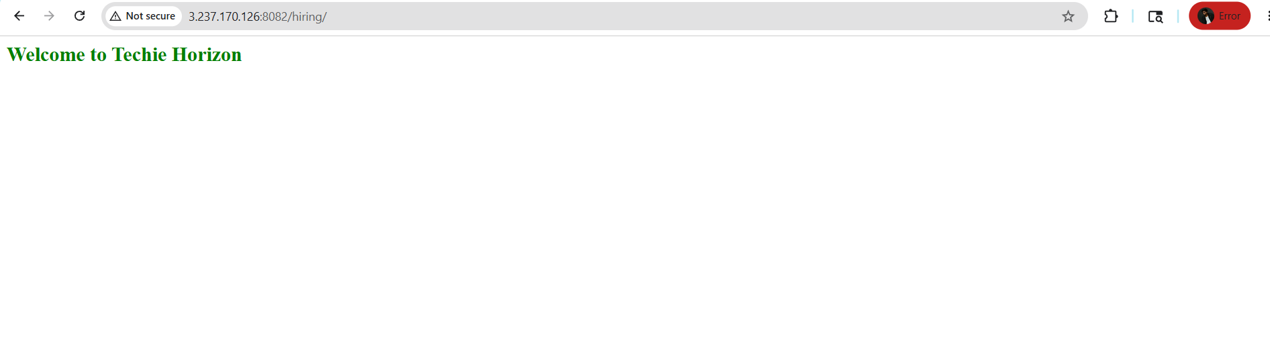

2) Setup a Jenkins CICD pipeline using Declarative pipeline using feature-1.1 branch.
Source Code: https://github.com/betawins/sabear_simplecutomerapp/tree/feature-1.1
stages:
- Git Clone
- SonarQube Integration
- Maven Compilation
- Nexus Artifactory
- Slack Notification
- Deploy On tomcat
First fork the source code into my git repo
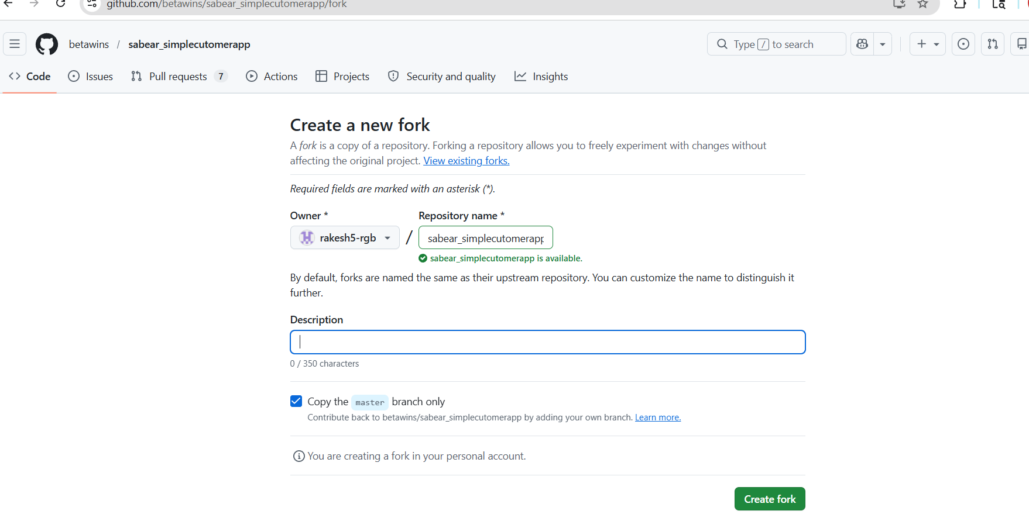
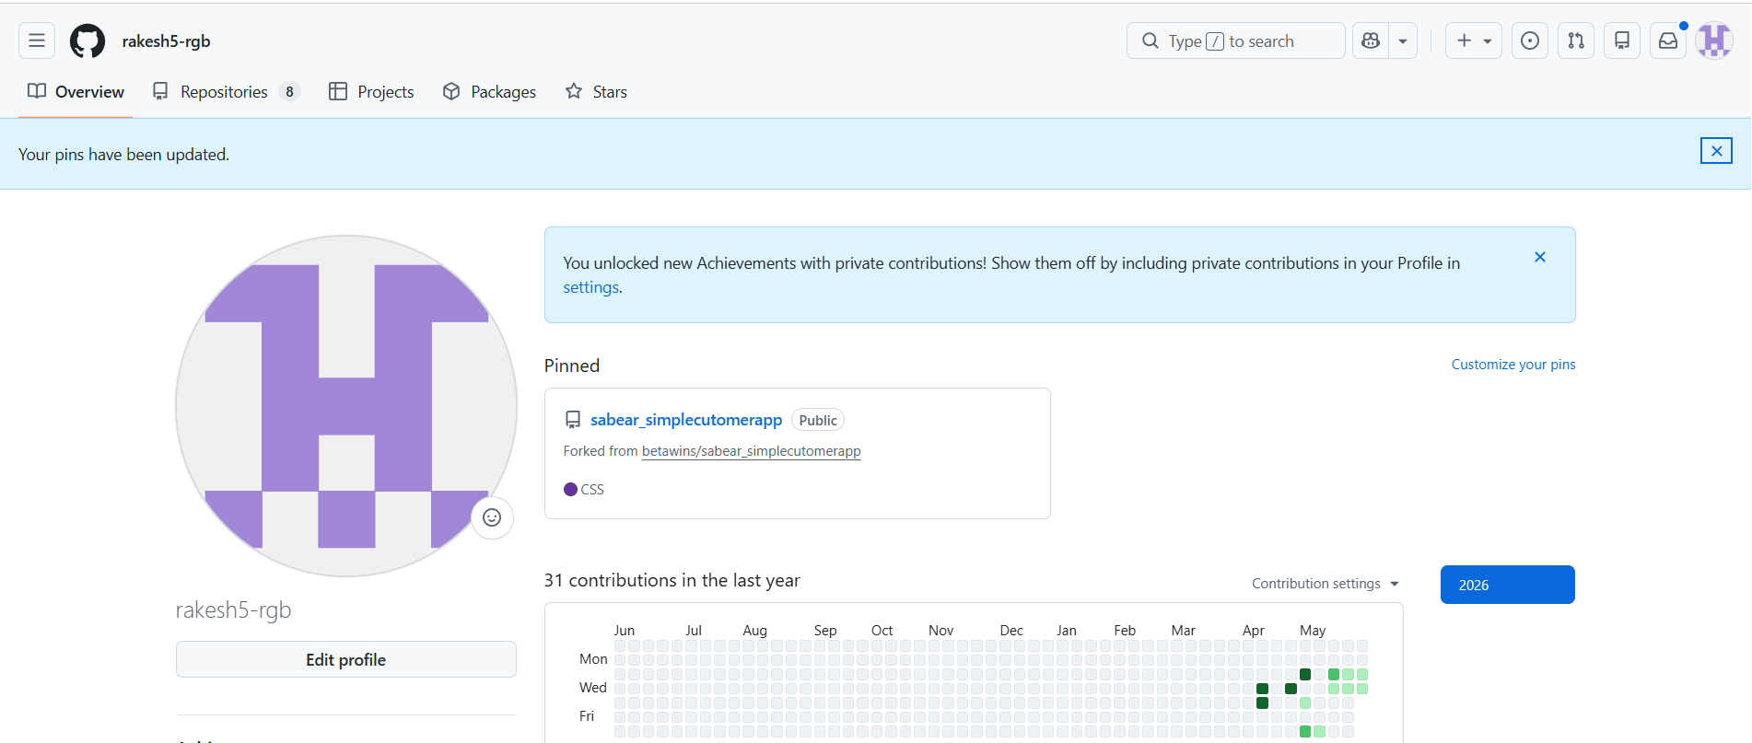
In Nexus created a new repo as Simplecustomerapp

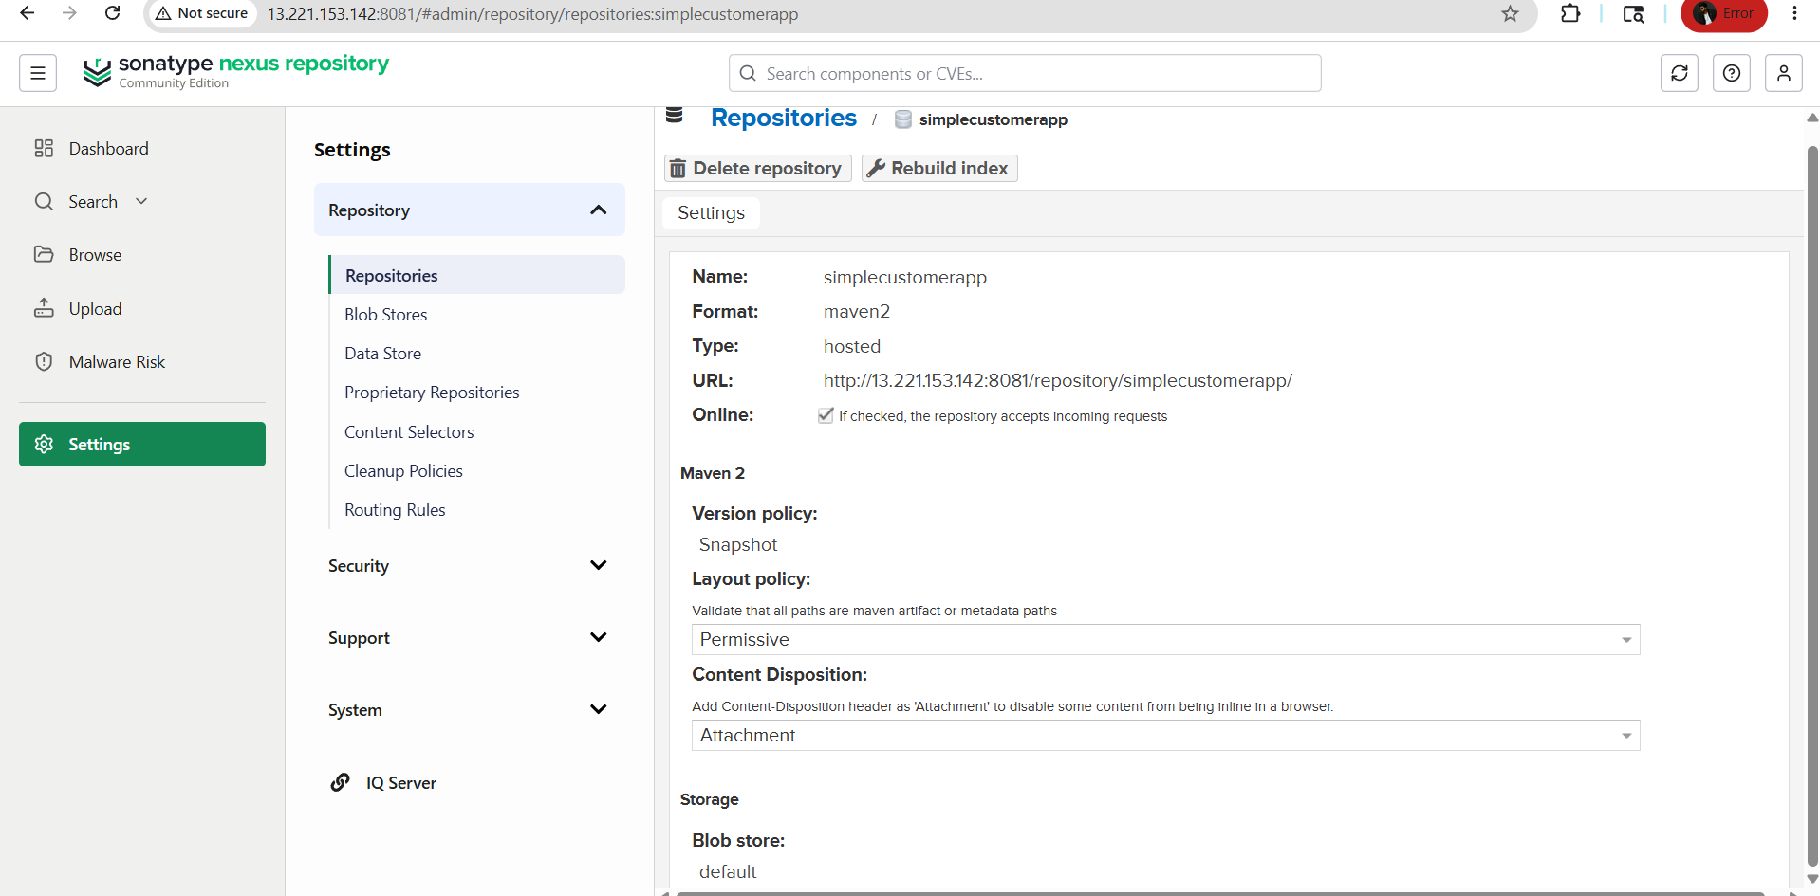
Already SonarQube, sonar-scanner, maven, nexus, tomcat all created and done
with plugins and configurations
➢ Create a New Item and selected pipeline

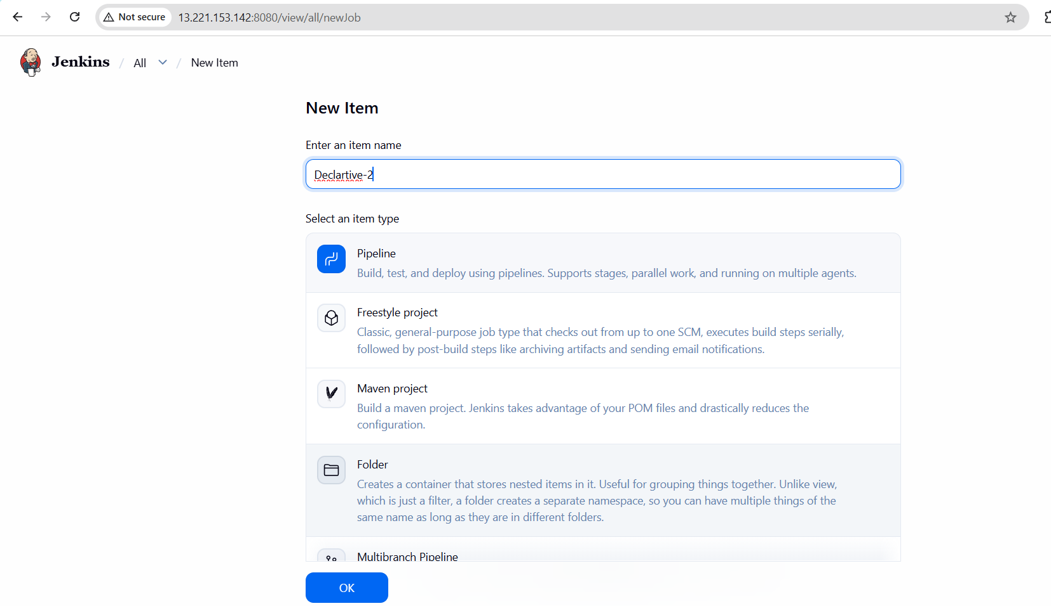
Now written the declarative pipeline and save it and build now
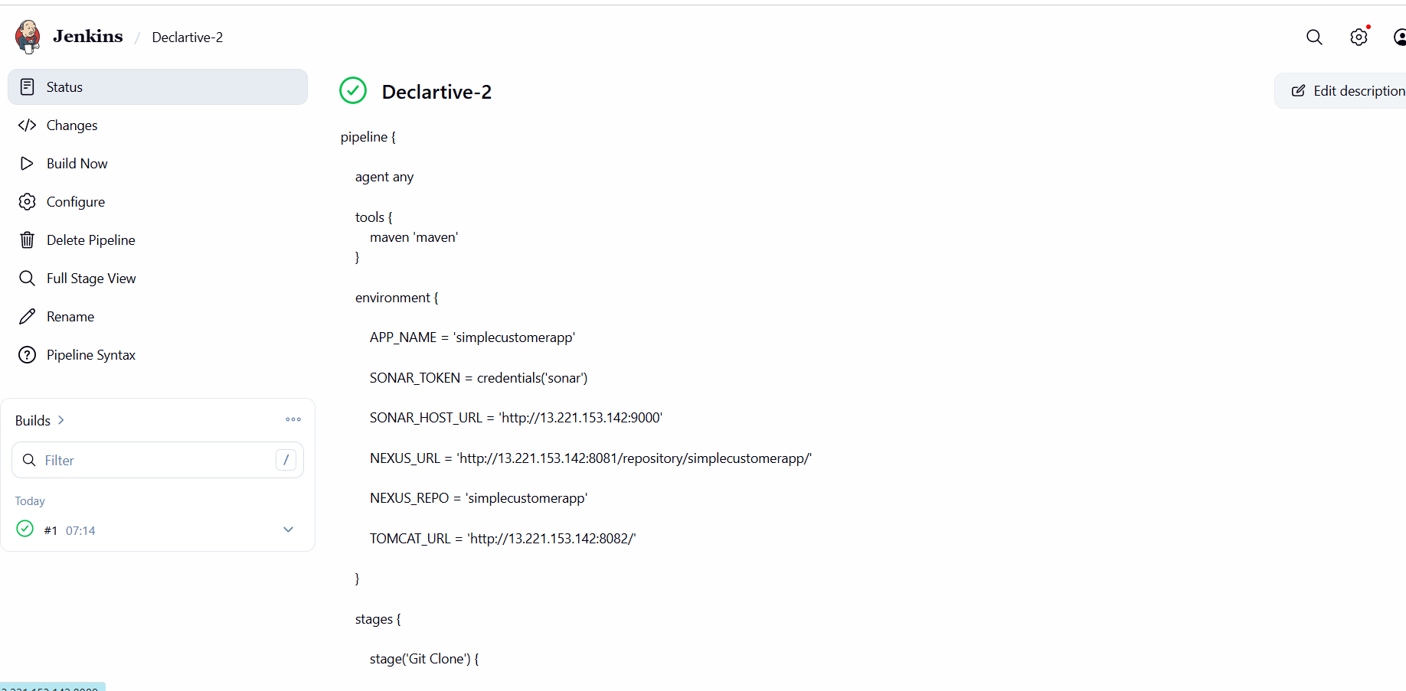
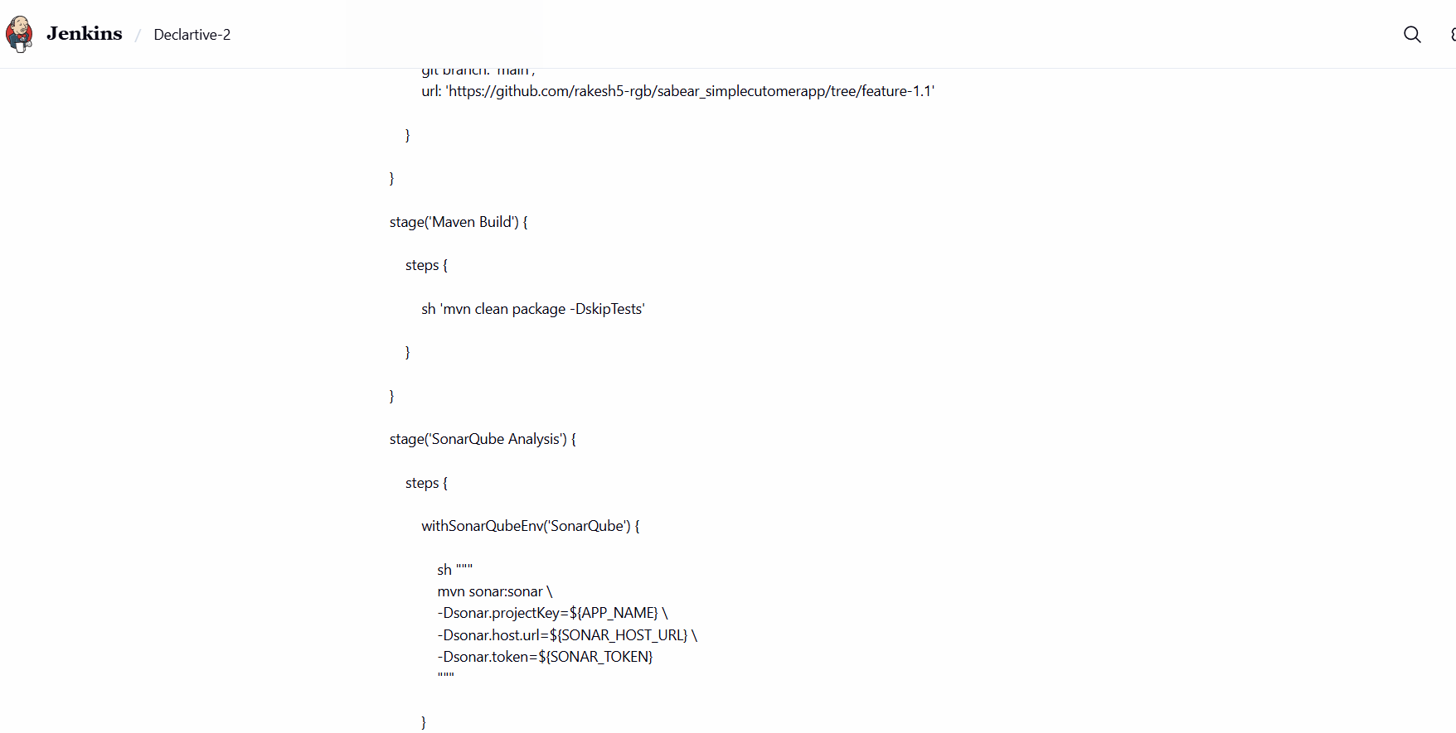
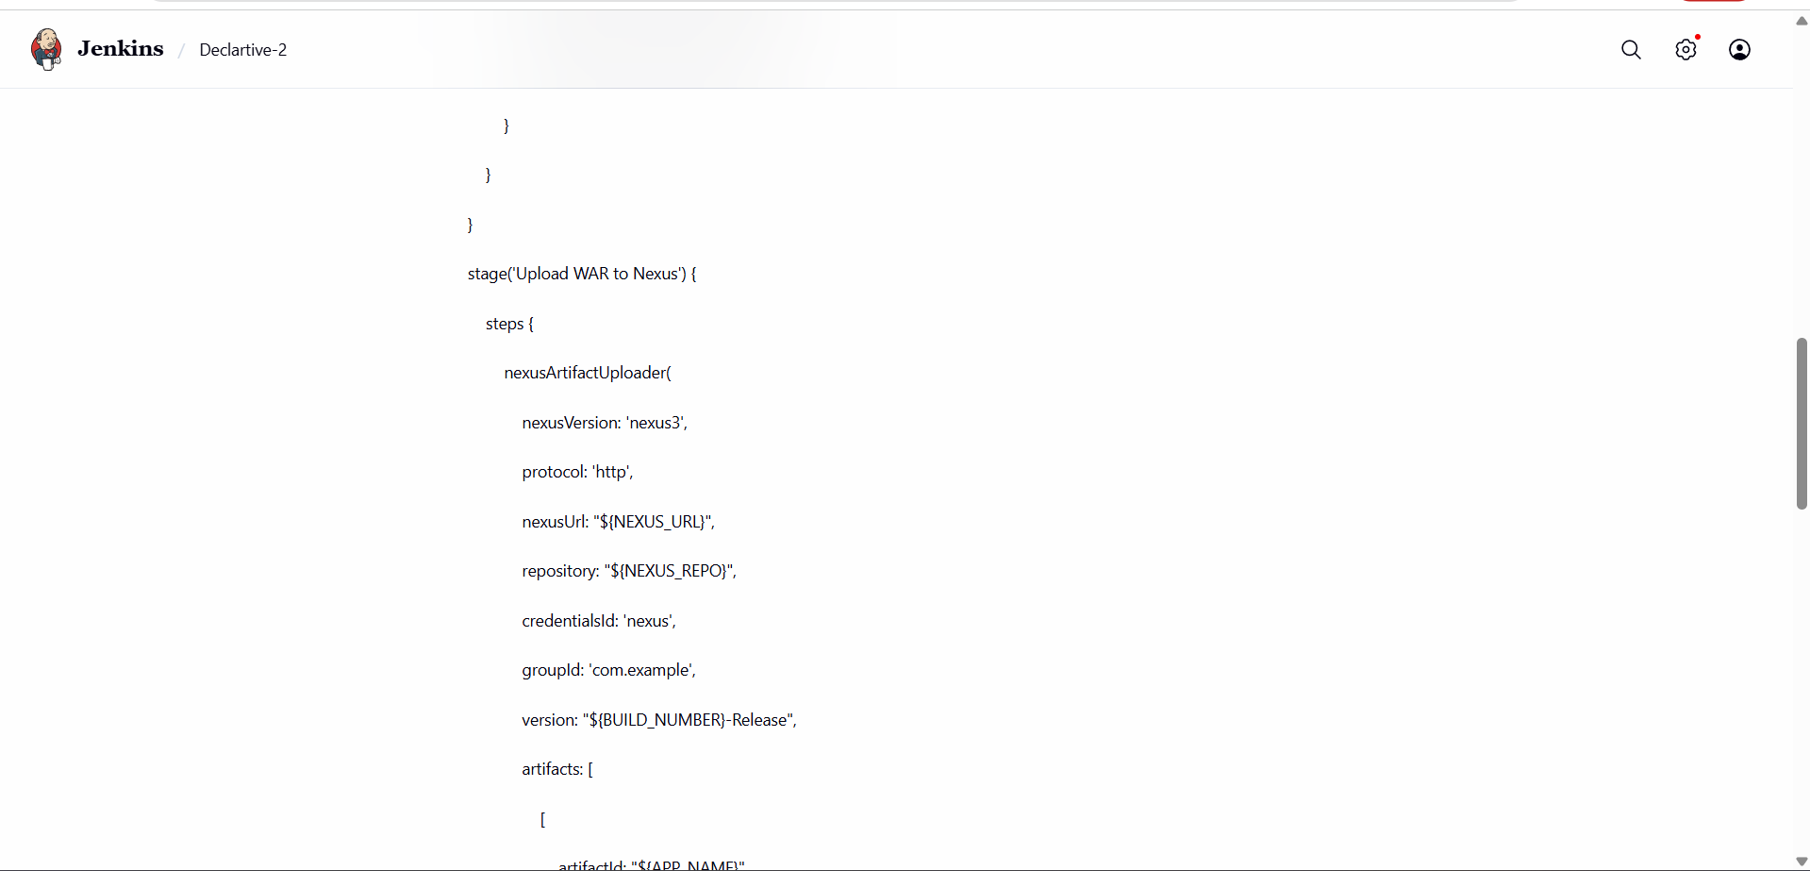
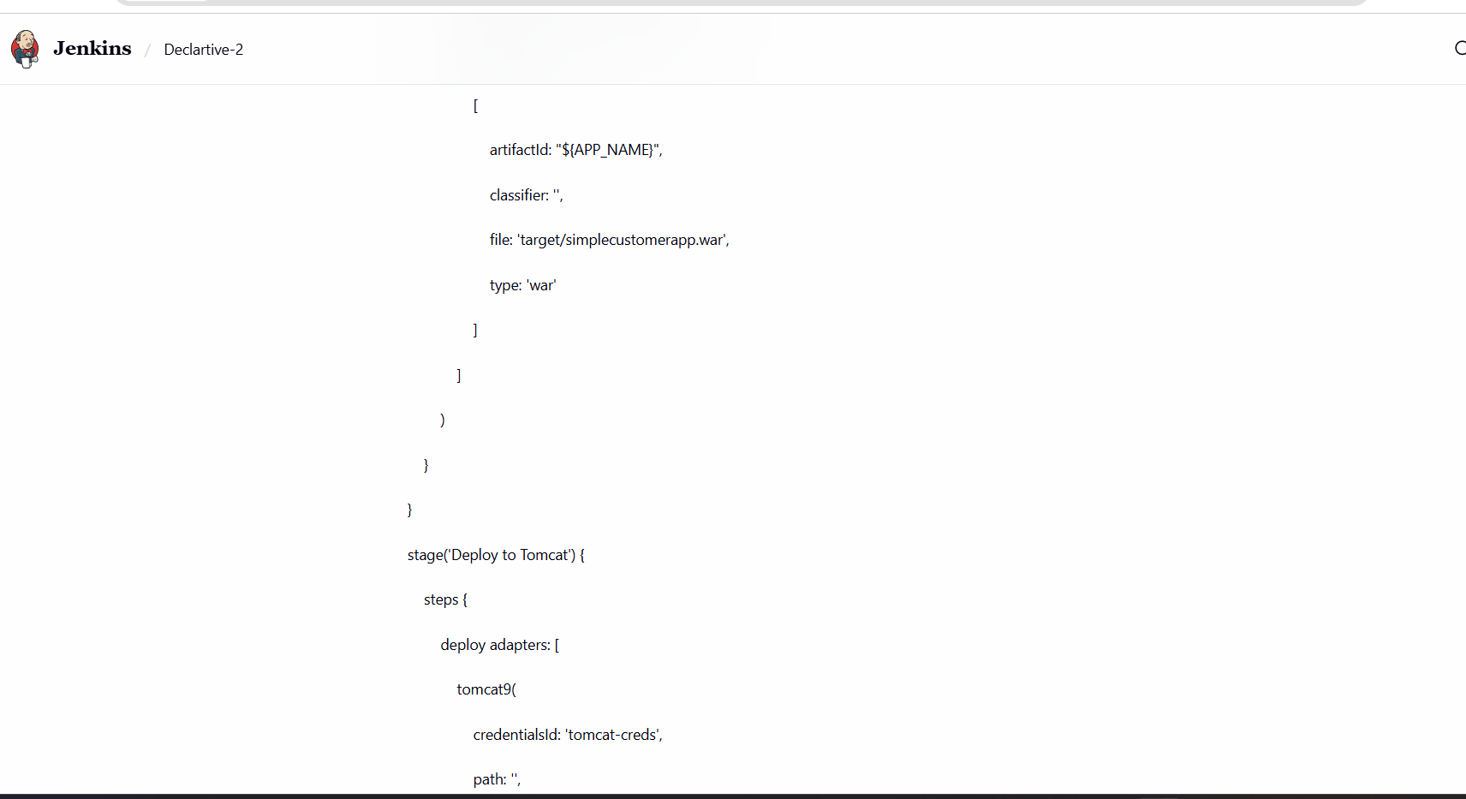
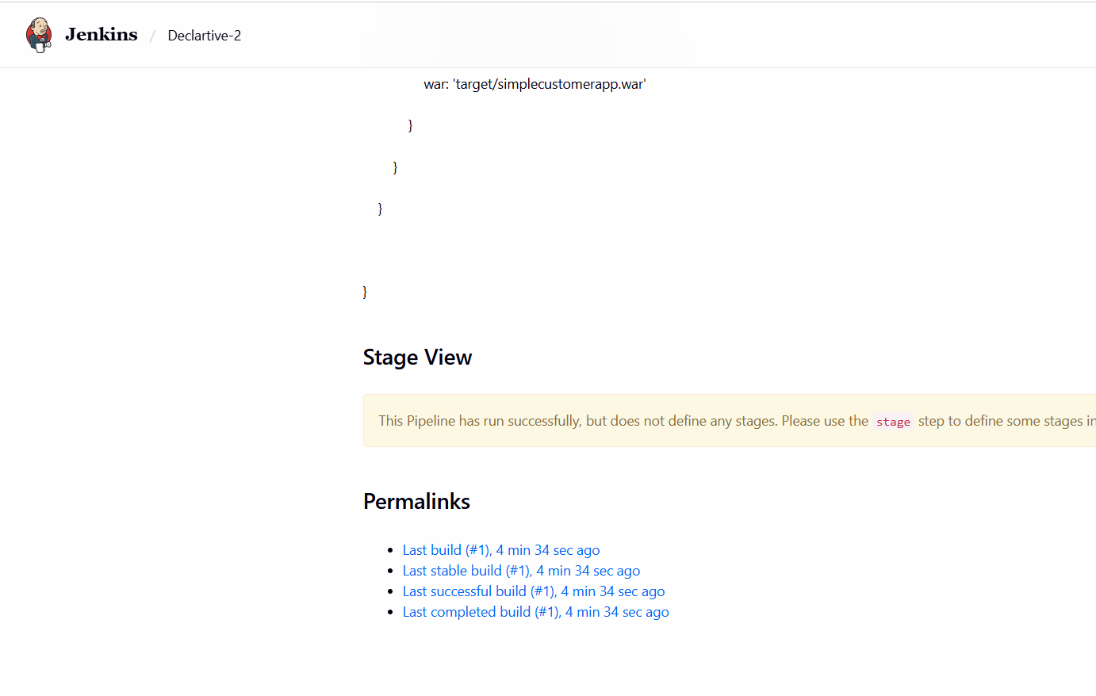
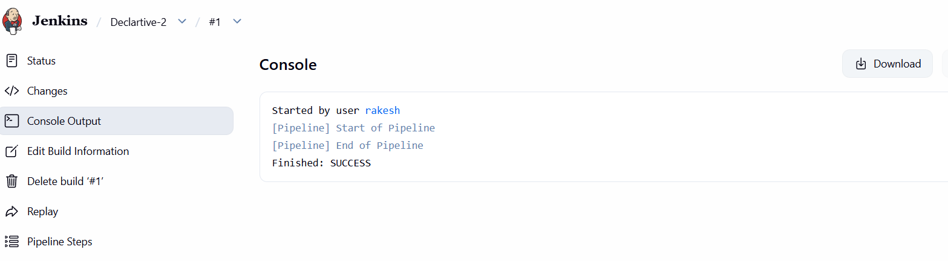

3) Setup a Jenkins CICD pipeline using Scripted pipeline using feature-1.1 branch.
Source Code: https://github.com/betawins/sabear_simplecutomerapp/tree/feature-1.1
stages:
- Git Clone
- SonarQube Integration
- Maven Compilation
- Nexus Artifactory
- Slack Notification
- Deploy On tomcat
- Git Clone:
- SonarQube Integration: changed the new ips of the instances in the
- Jenkins server:
- Maven Compilation- changed the new ips of the instances in the Jenkins
- server:
- Nexus Artifactory: Created a new repo in nexus and configured it with
- the below script: pipeline
- node {

- def APP_NAME = 'hiring-app'
- def SONAR_HOST_URL = 'http://13.221.153.142:9000'
- def NEXUS_URL = '13.221.153.142:8081'
- def NEXUS_REPO = 'hiring-releases'
- def TOMCAT_URL = 'http://3.237.170.126:8082'

- // Maven Tool Configuration
- def mvnHome = tool name: 'maven', type: 'maven'

- // Sonar Token Credentials
- withCredentials([
- string(credentialsId: 'sonar', variable: 'SONAR_TOKEN')
- ]) {

- stage('Git Clone') {

- git branch: 'main',
- url: 'https://github.com/rakesh5-rgb/hiring-app.git'
- }

- stage('Maven Build') {

- sh "${mvnHome}/bin/mvn clean package -DskipTests"
- }

- stage('SonarQube Analysis') {

- withSonarQubeEnv('SonarQube') {

- sh """
- ${mvnHome}/bin/mvn sonar:sonar \
- -Dsonar.projectKey=${APP_NAME} \
- -Dsonar.host.url=${SONAR_HOST_URL} \
- -Dsonar.token=${SONAR_TOKEN}
- """
- }
- }

- stage('Upload WAR to Nexus') {

- nexusArtifactUploader(

- nexusVersion: 'nexus3',

- protocol: 'http',

- nexusUrl: "${NEXUS_URL}",

- repository: "${NEXUS_REPO}",

- credentialsId: 'nexus',

- groupId: 'com.example',

- version: "${BUILD_NUMBER}-Release",

- artifacts: [

- [

- artifactId: "${APP_NAME}",

- classifier: '',

- file: 'target/hiring.war',

- type: 'war'
- ]
- ]
- )
- }

- stage('Deploy to Tomcat') {

- deploy adapters: [

- tomcat9(

- credentialsId: 'tomcat-creds',

- path: '',

- url: "${TOMCAT_URL}"
- )

- ],

- contextPath: 'hiring',

- war: 'target/hiring.war'
- }
- }
- }
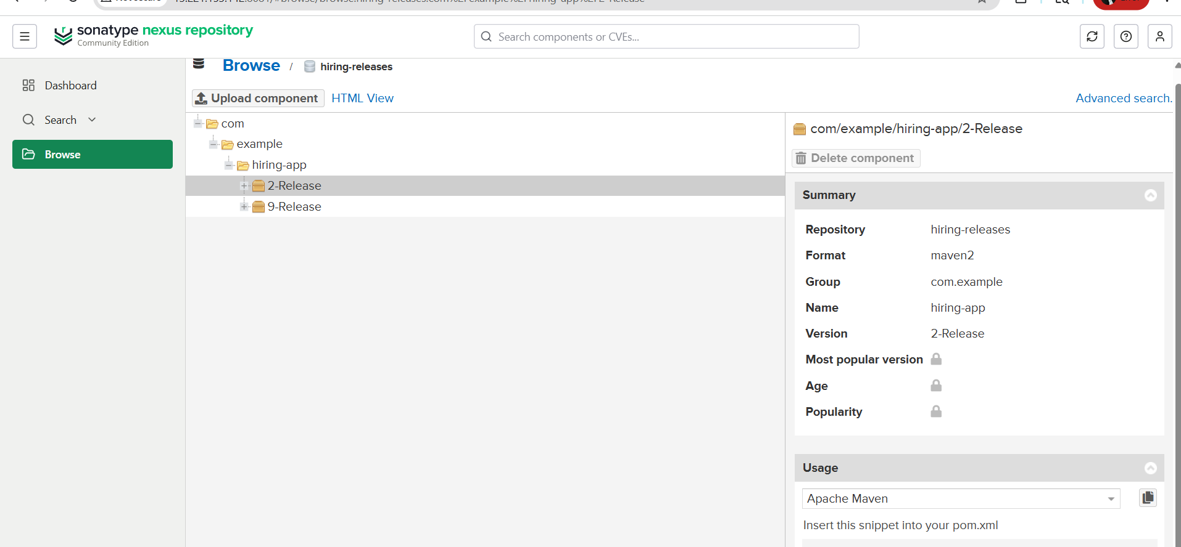
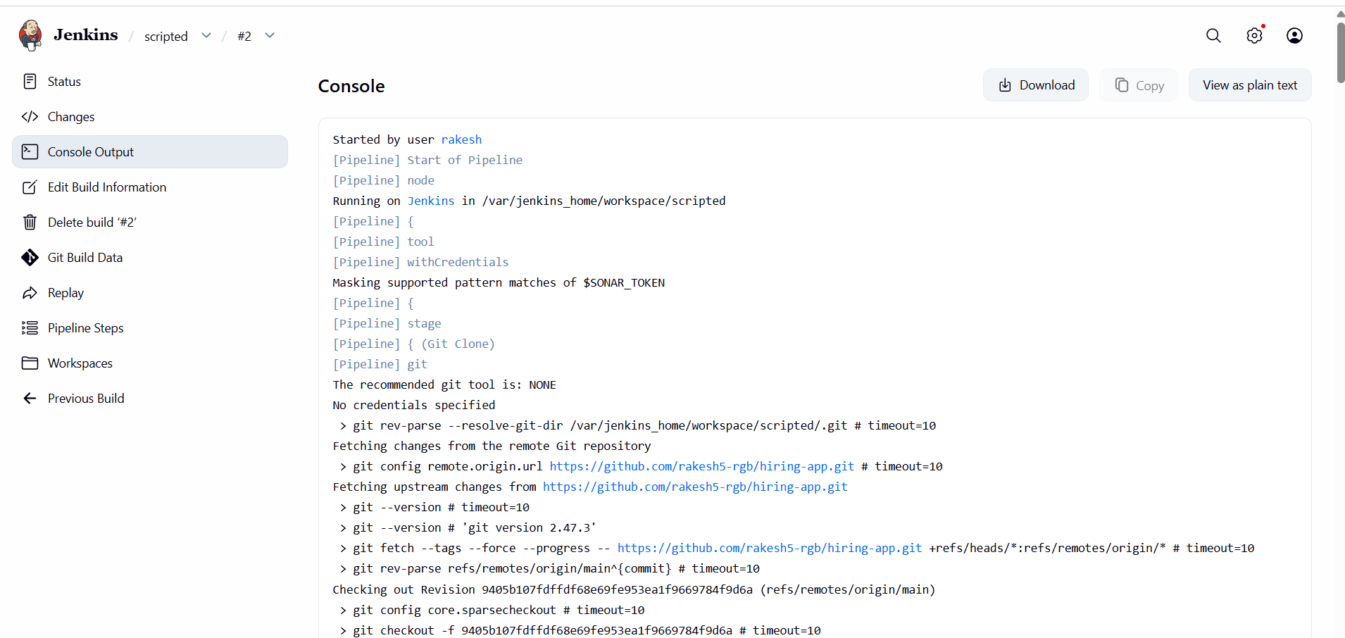
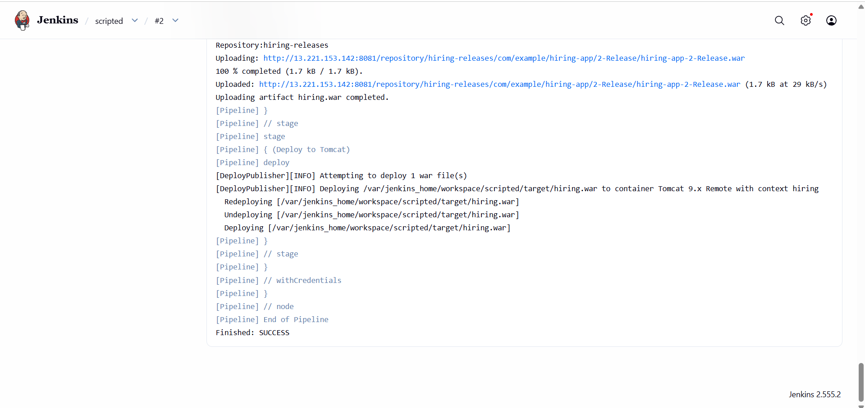
- So the build now worked in the last with the help of above pipeline Script
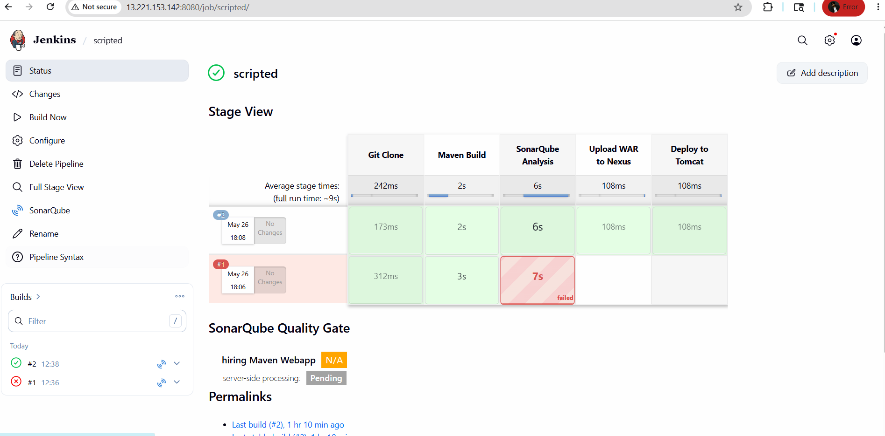

4) Write sample skeleton of pipelines.
Declarative Pipeline
pipeline {
agent any
tools {
maven 'maven'
}
environment {
APP_NAME = 'hiring-app'
SONAR_TOKEN = credentials('sonar')
SONAR_HOST_URL = 'http://13.221.153.142:9000'
NEXUS_URL = '13.221.153.142:8081'
NEXUS_REPO = 'hiring-releases'
TOMCAT_URL = 'http://3.237.170.126:8082'
}
stages {
stage('Git Clone') {
steps {
git branch: 'main',
url: 'https://github.com/rakesh5-rgb/hiring-app.git'
}
}
stage('Maven Build') {
steps {
sh 'mvn clean package -DskipTests'
}
}
stage('SonarQube Analysis') {
steps {
withSonarQubeEnv('SonarQube') {
sh """
mvn sonar:sonar \
-Dsonar.projectKey=${APP_NAME} \
-Dsonar.host.url=${SONAR_HOST_URL} \
-Dsonar.token=${SONAR_TOKEN}
"""
}
}
}
stage('Upload WAR to Nexus') {
steps {
nexusArtifactUploader(
nexusVersion: 'nexus3',
protocol: 'http',
nexusUrl: "${NEXUS_URL}",
repository: "${NEXUS_REPO}",
credentialsId: 'nexus',
groupId: 'com.example',
version: "${BUILD_NUMBER}-Release",
artifacts: [
[
artifactId: "${APP_NAME}",
classifier: '',
file: 'target/hiring.war',
type: 'war'
]
]
)
}
}
stage('Deploy to Tomcat') {
steps {
deploy adapters: [
tomcat9(
credentialsId: 'tomcat-creds',
path: '',
url: "${TOMCAT_URL}"
)
],
contextPath: 'hiring',
war: 'target/hiring.war'
}
}
}
}
5) Create a parameterized job in Jenkins.
Source Code: https://github.com/betawins/spring3-mvc-maven-xml-hello-world-1.git
First fork the git into my repo
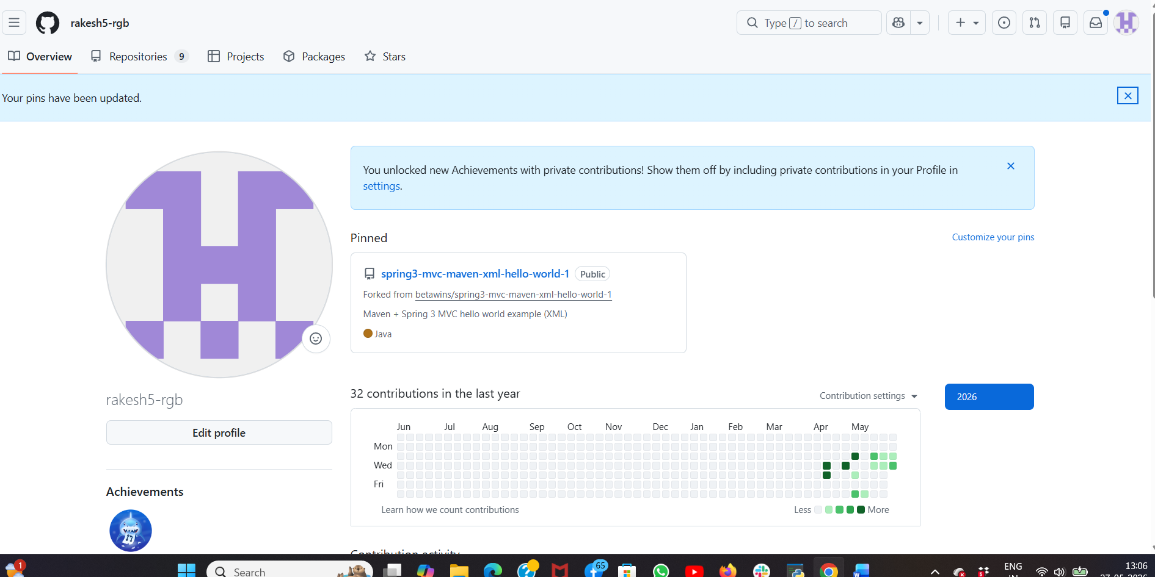
Created a new item in jenkins and selected freestyle project
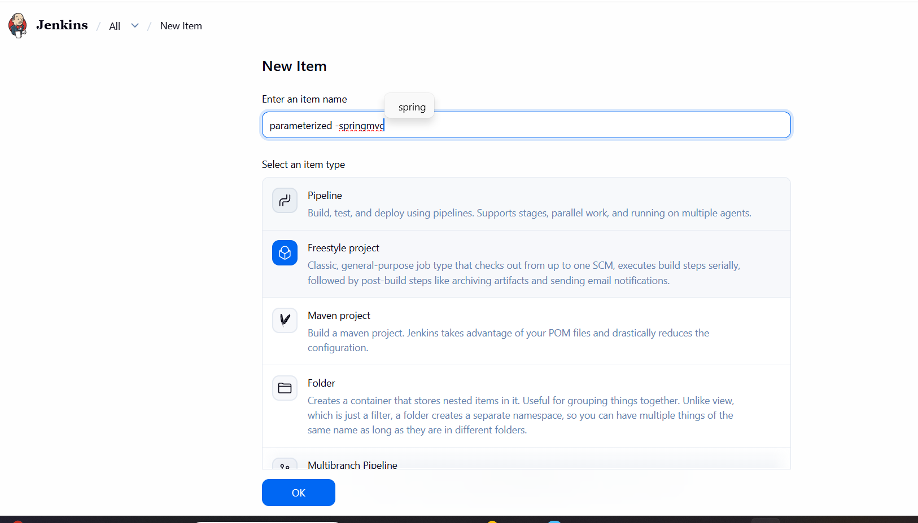
Selected Parameter and add parameter
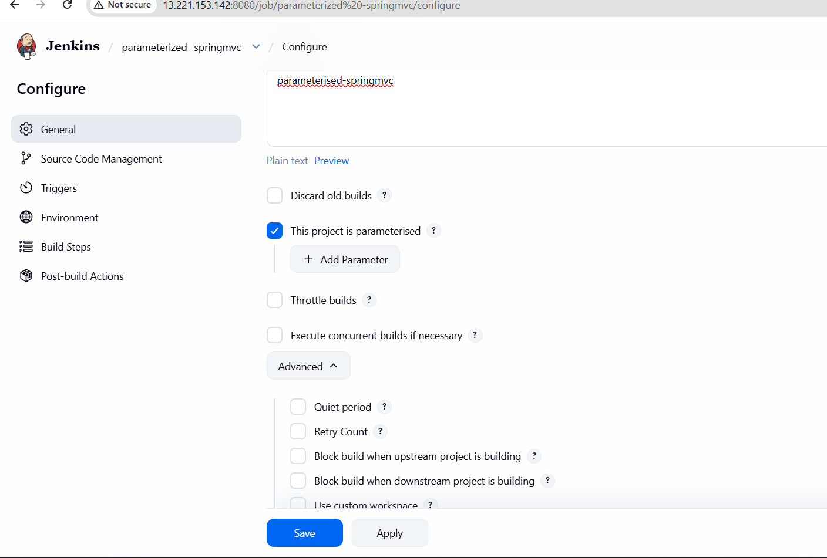
In parameter selected string parameter added branch and master
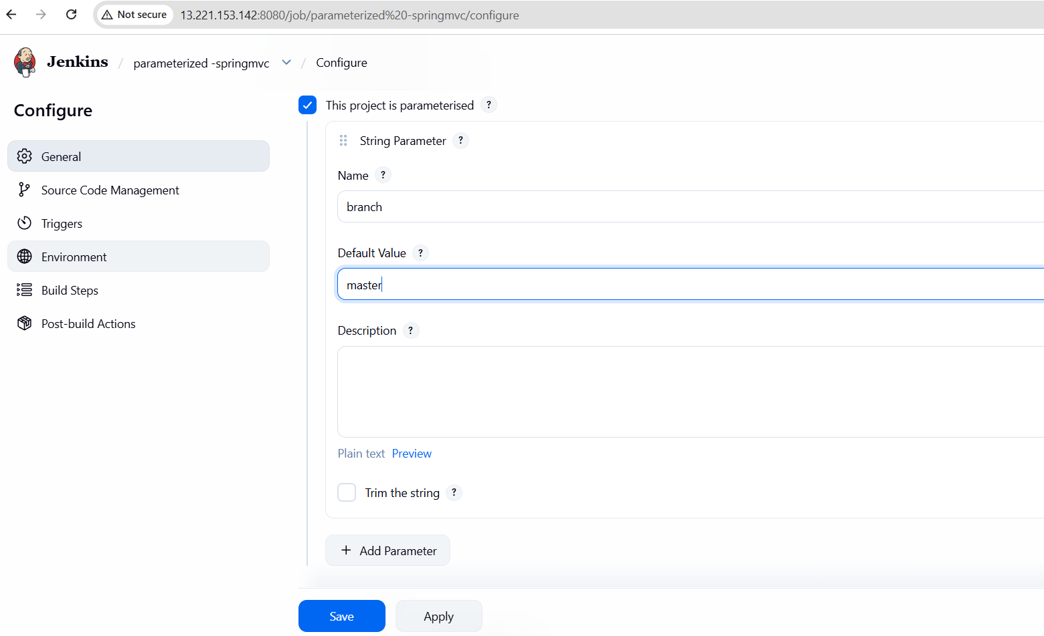
In Source code management select git and add URL
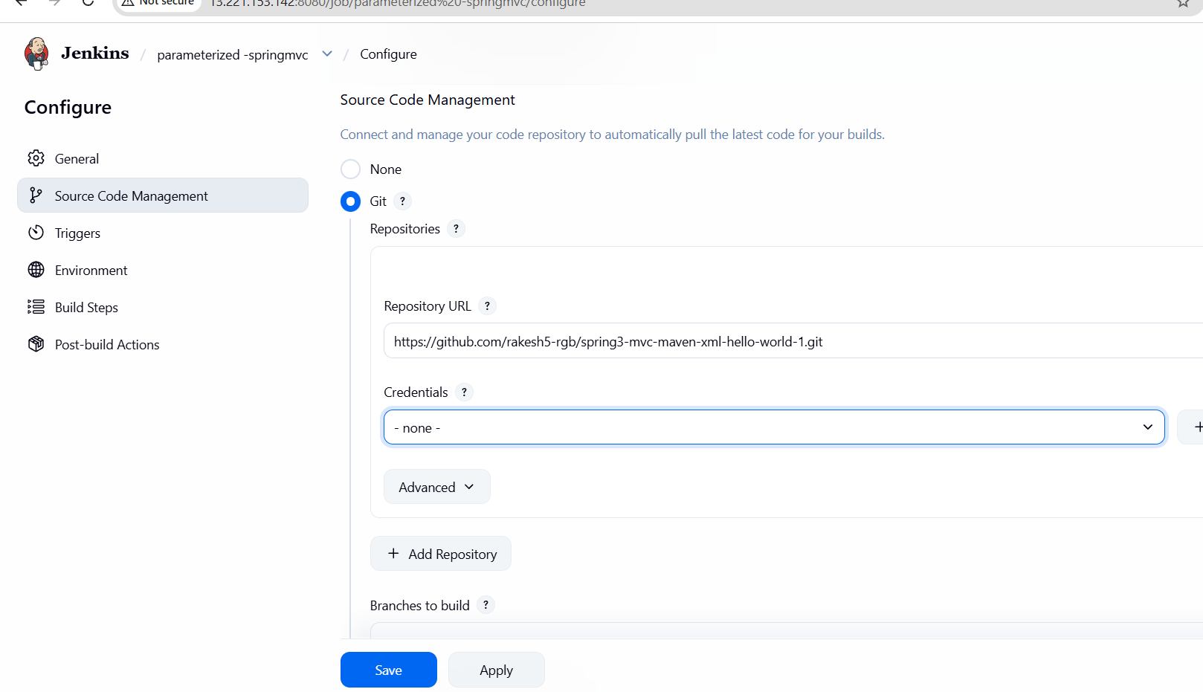
In Build steps select maven and given maven version and save
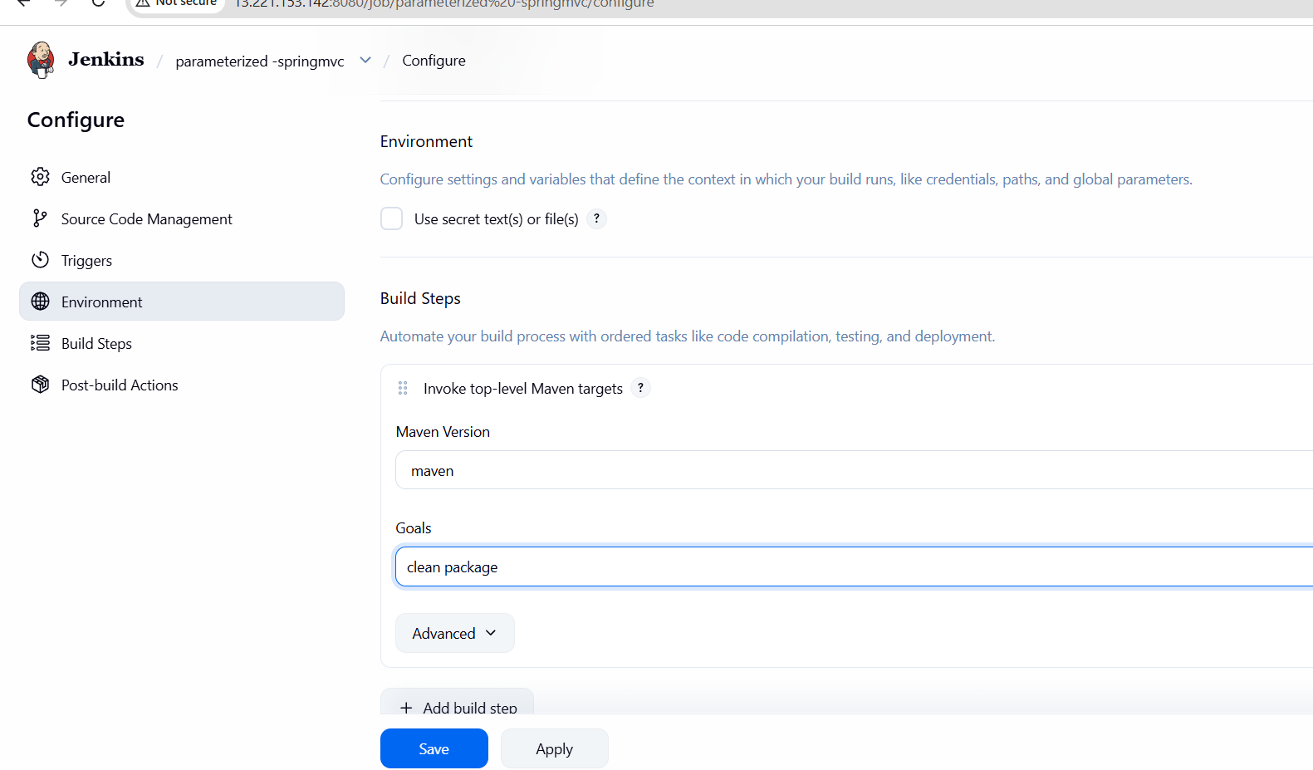
After save Build with parameters
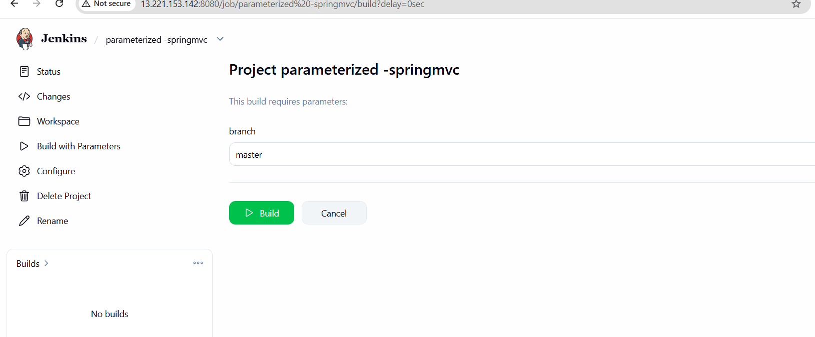
In console we can check Build success
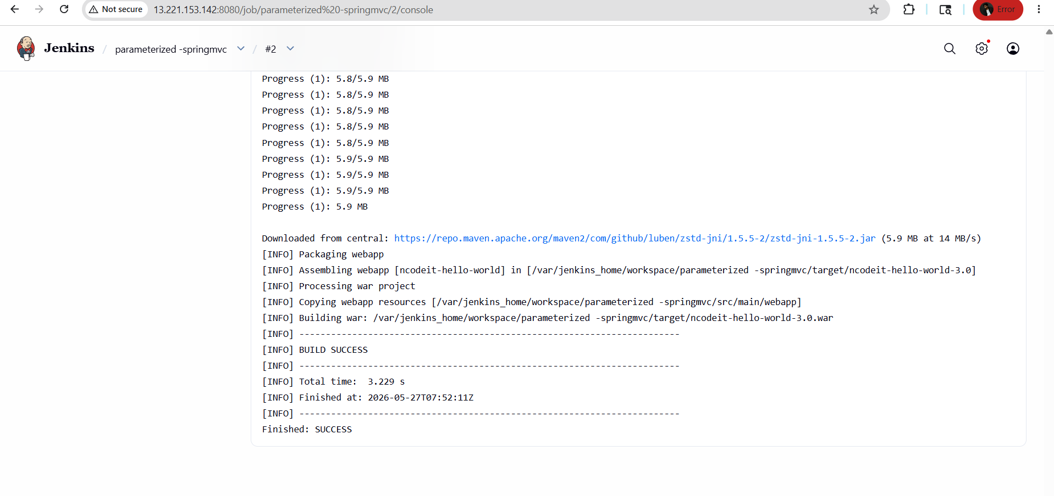

6) Setup one slave machine for Jenkins.
Lets create instance
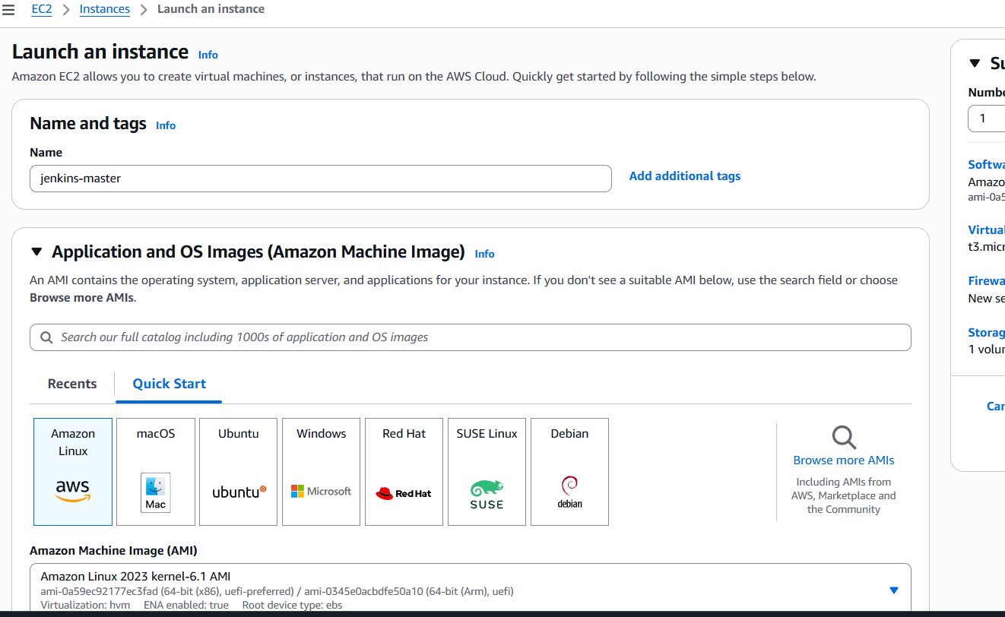
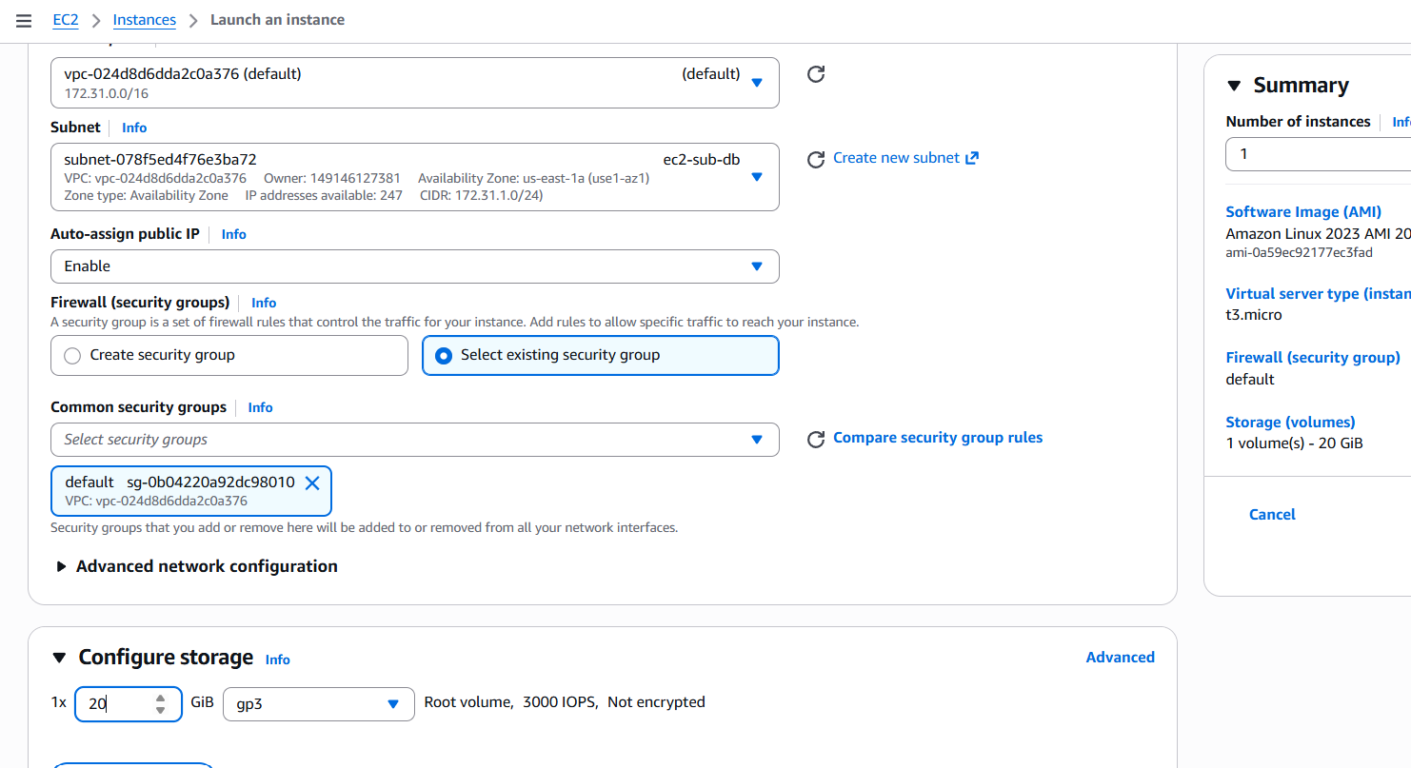
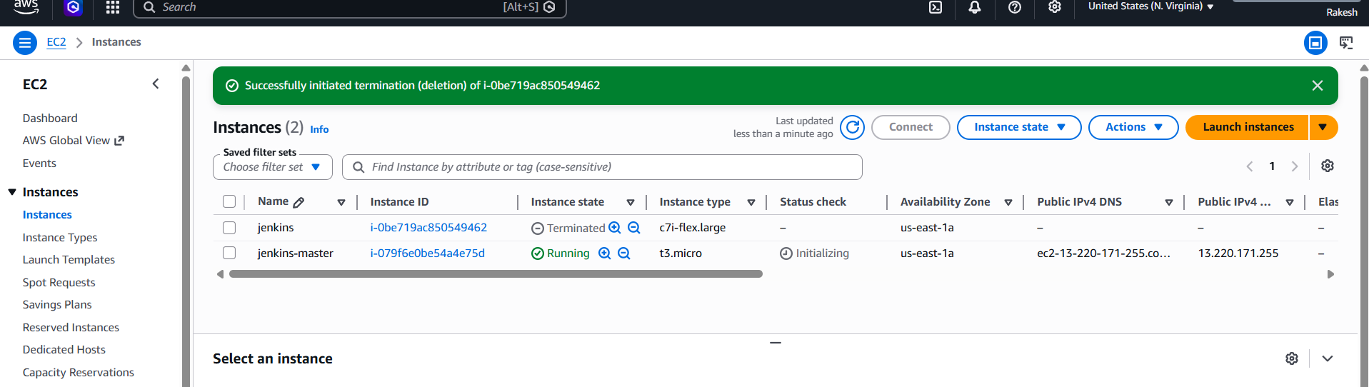
And create 2 instances for 2slaves
Here we have created three instances
- Jenkins Master
- Slave-1
- Slave-2
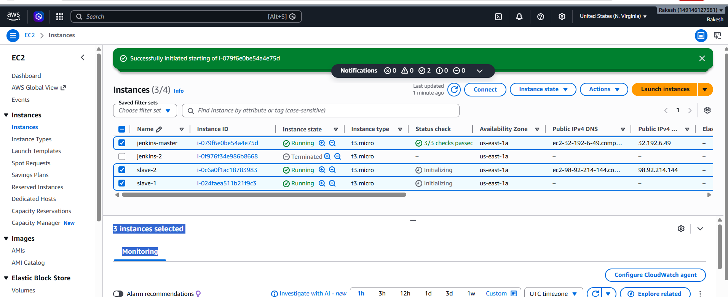
Connect to Jenkins master
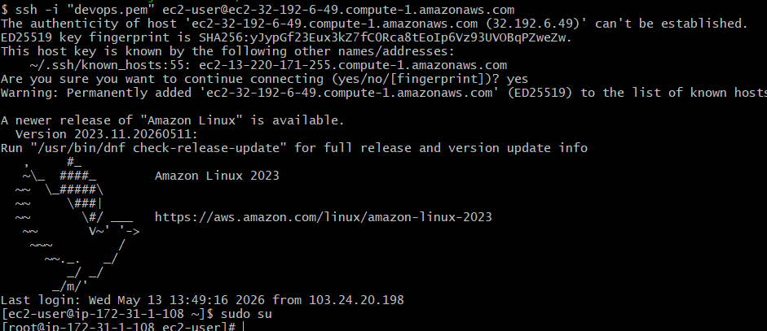

Install Jenkins
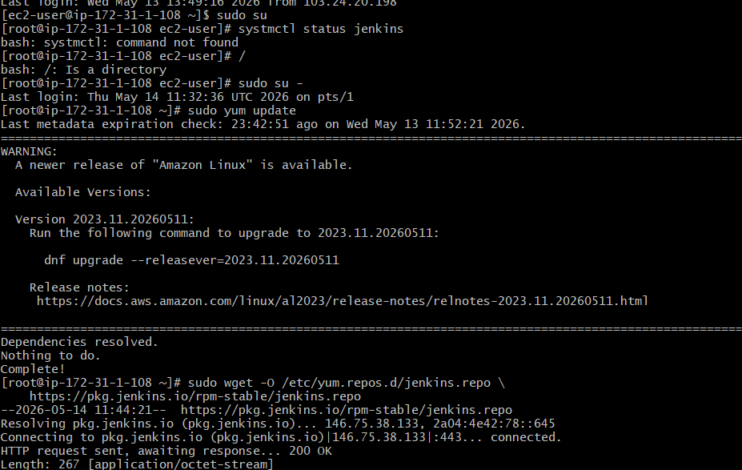
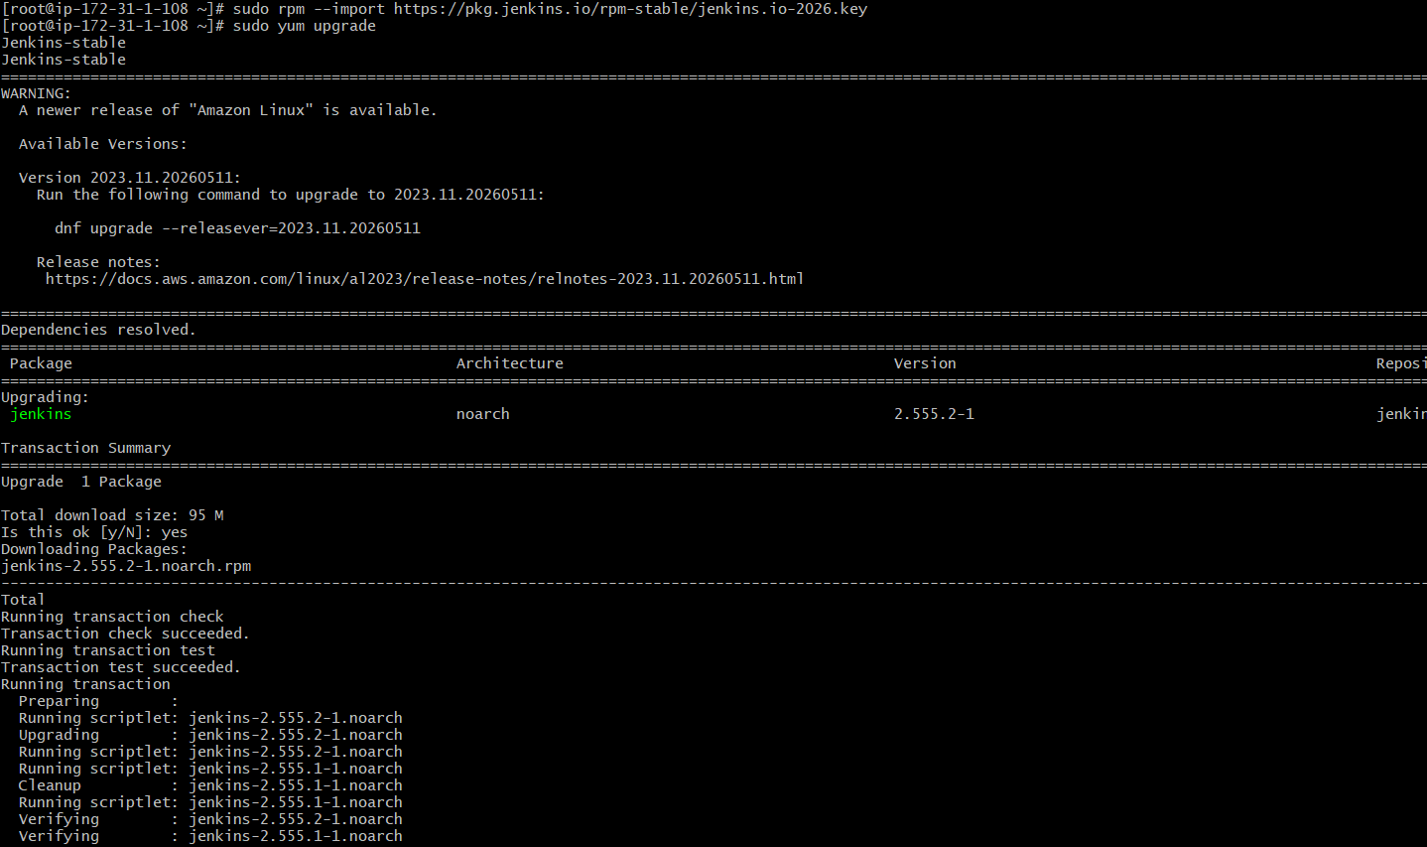
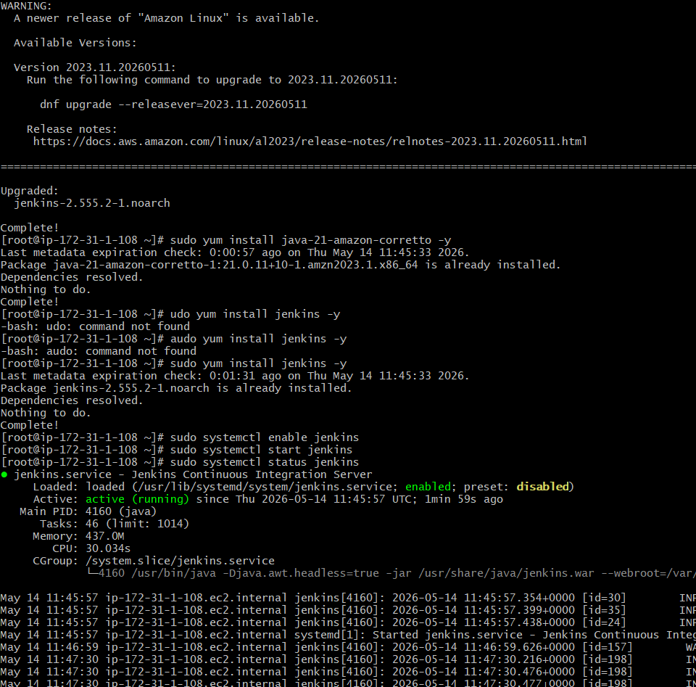

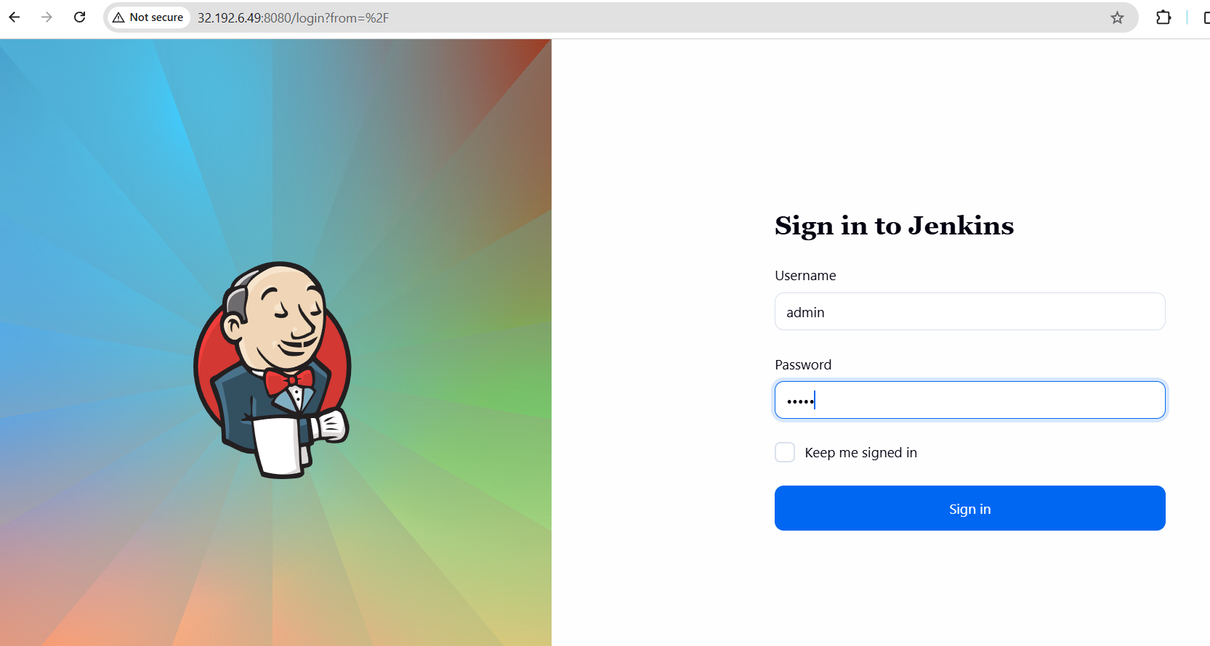
Login to both the slaves through ssh
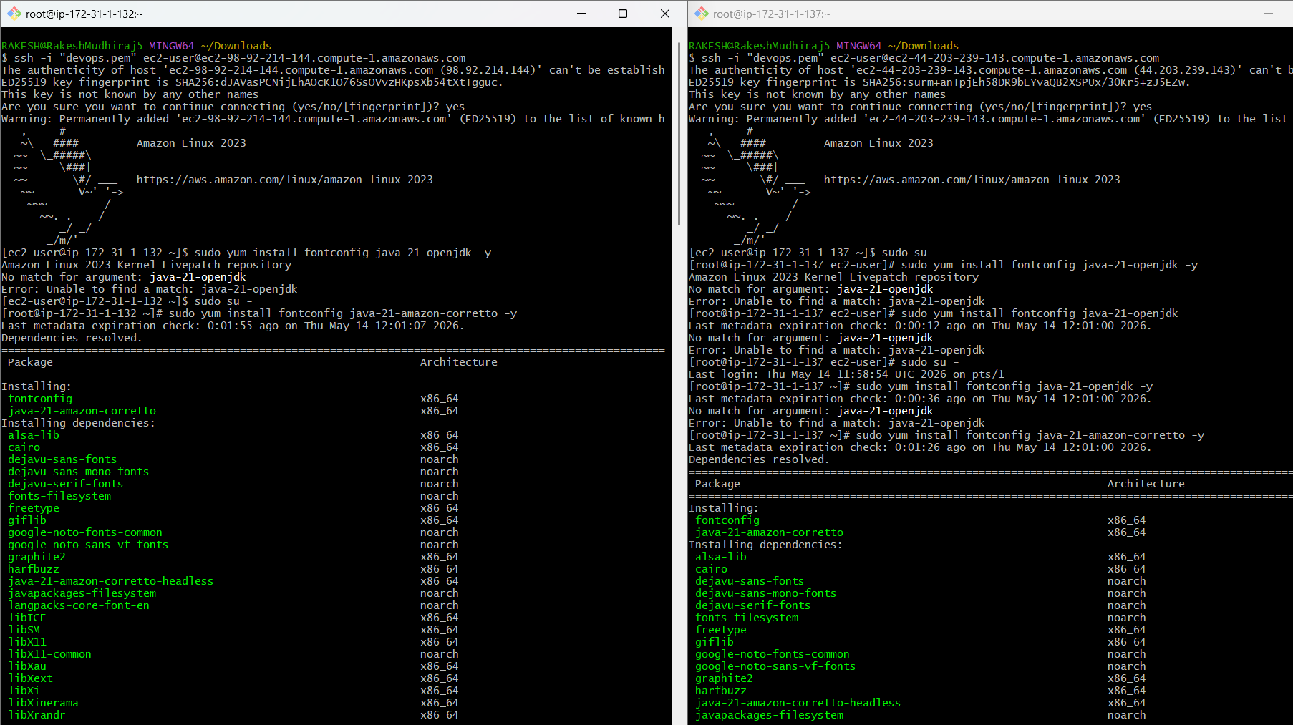
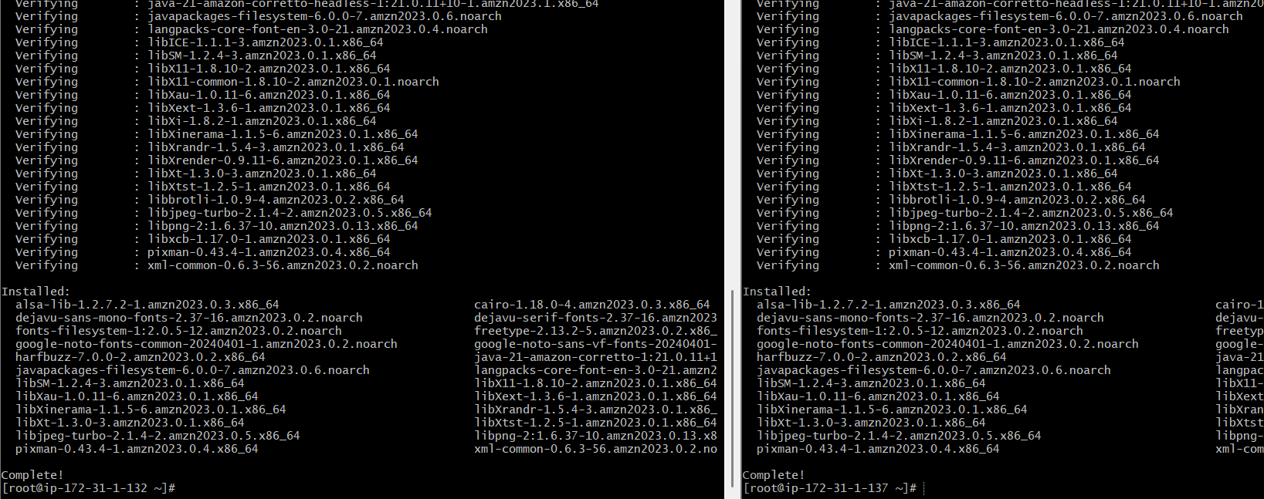

Install java in both slaves
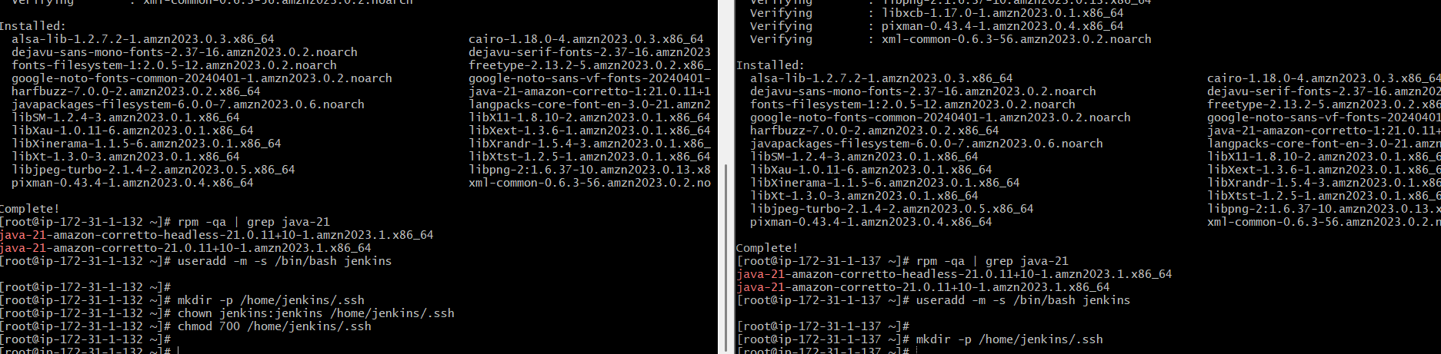
Create jenkins user
Create .ssh directory for jenkins use

Prepare the Jenkins Controller (Master) – we need to do in Jenkins-master server
Ensure the 'jenkins' user exists
# The Jenkins RPM package normally creates this user automatically.
# This command checks and creates it only if missing.
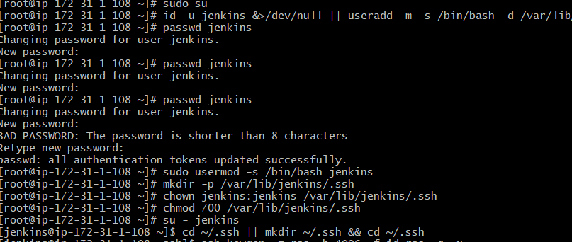
Now switch to Jenkins user -- Navigate to .ssh directory
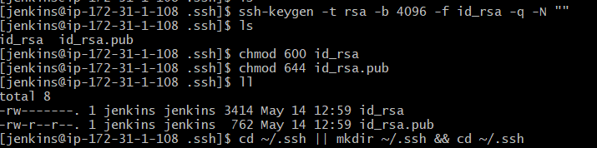
Generate RSA key pair
Set correct permission
Display the public key (you will need it for slaves) -- exit back to root
Public key: `/var/lib/jenkins/.ssh/id_rsa.pub`
Private key: /var/lib/jenkins/.ssh/id_rsa
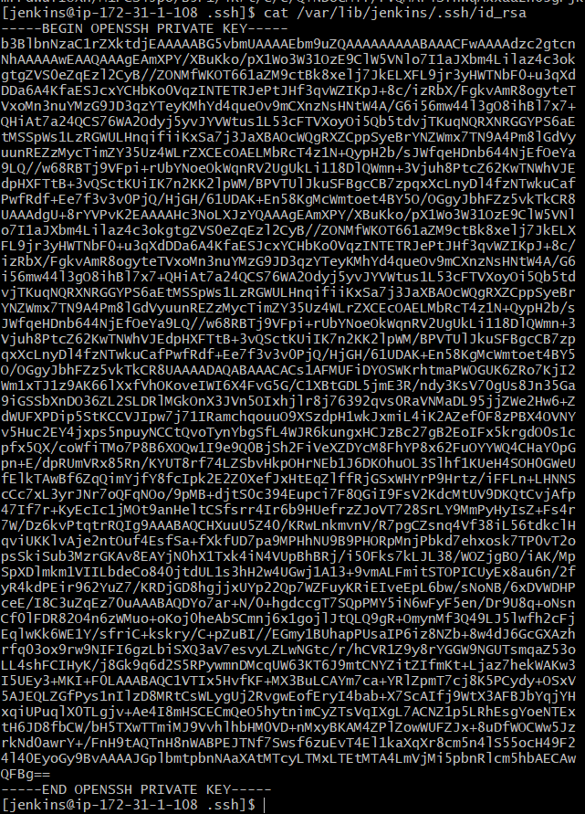

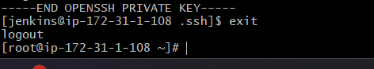
Copy the Public Key to Both Agents
In both slave01 & slave02
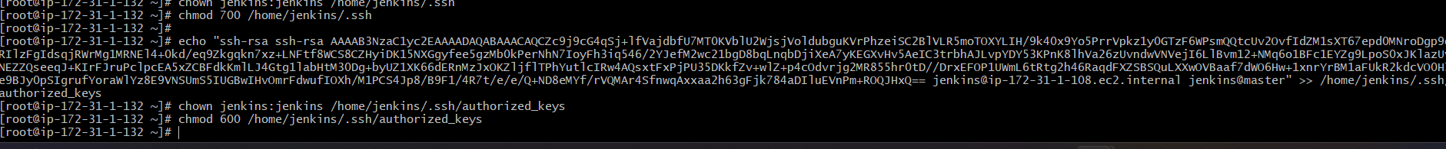
Add Agents' Host Keys to known_hosts
Go to Jenkins server
Slave-1 and slave -2
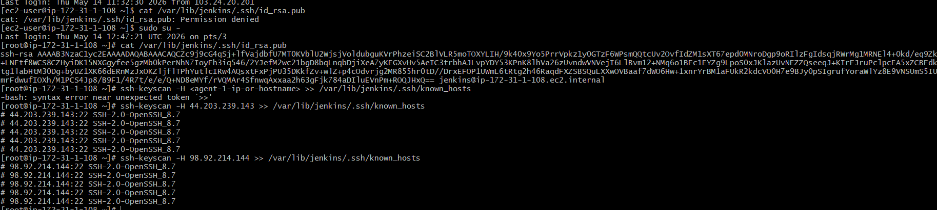
Fix ownership and permissions
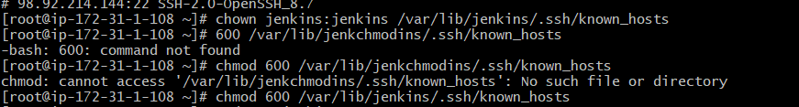
Test Password-less SSH Connectivity (From Master to Slave Machines)
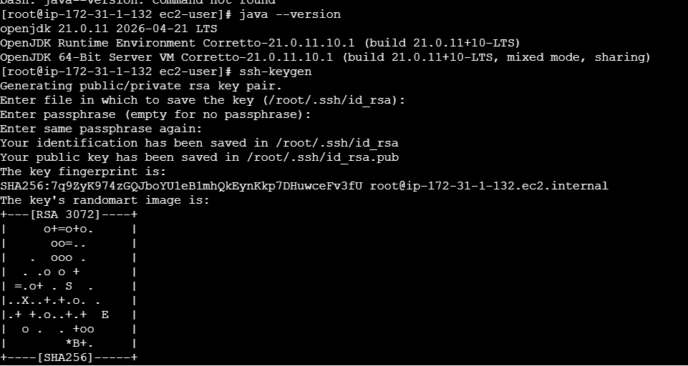

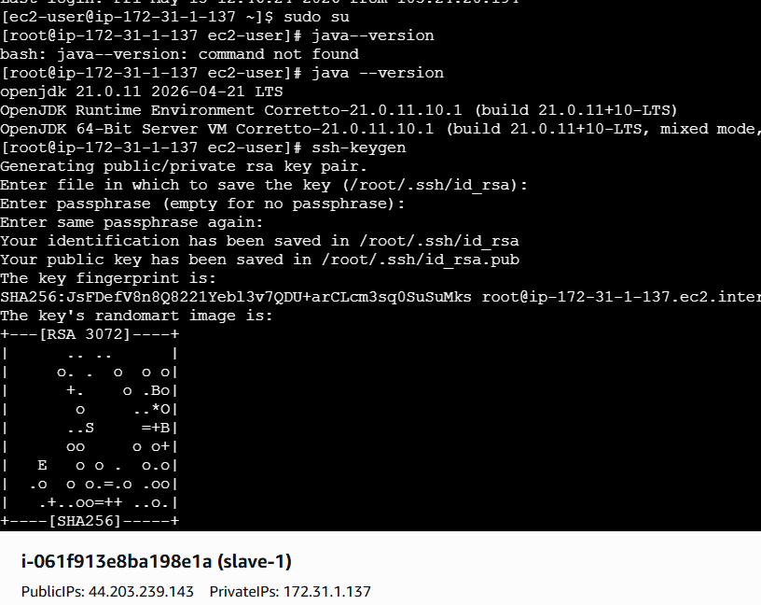

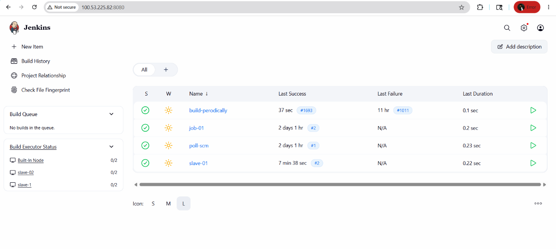
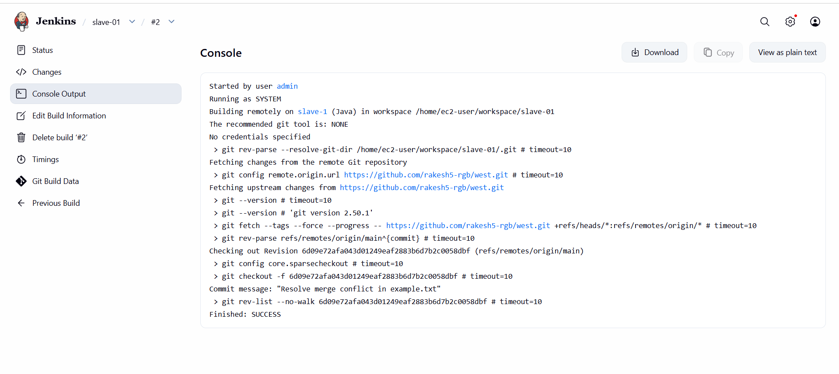
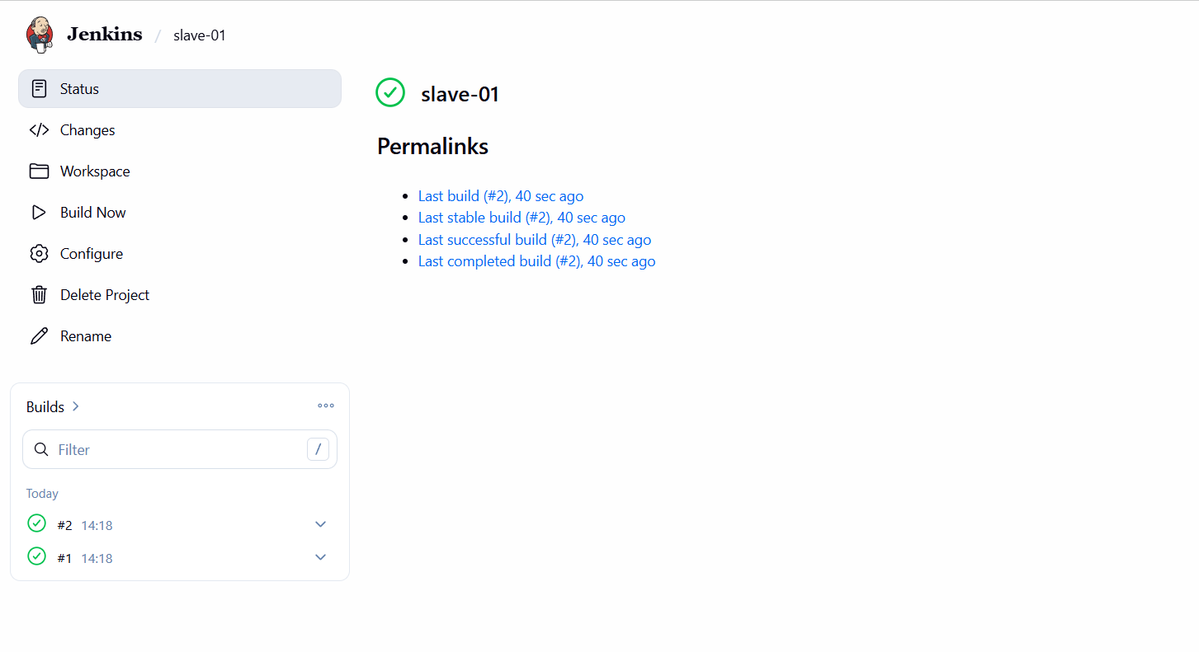

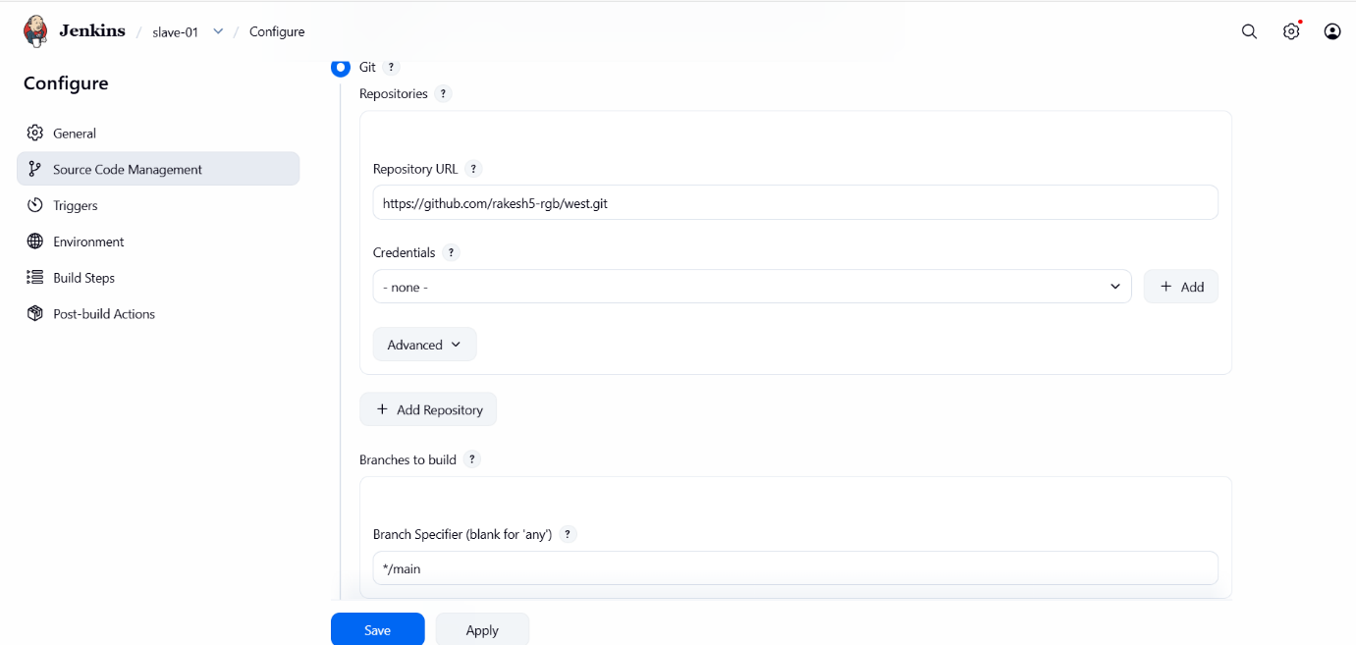
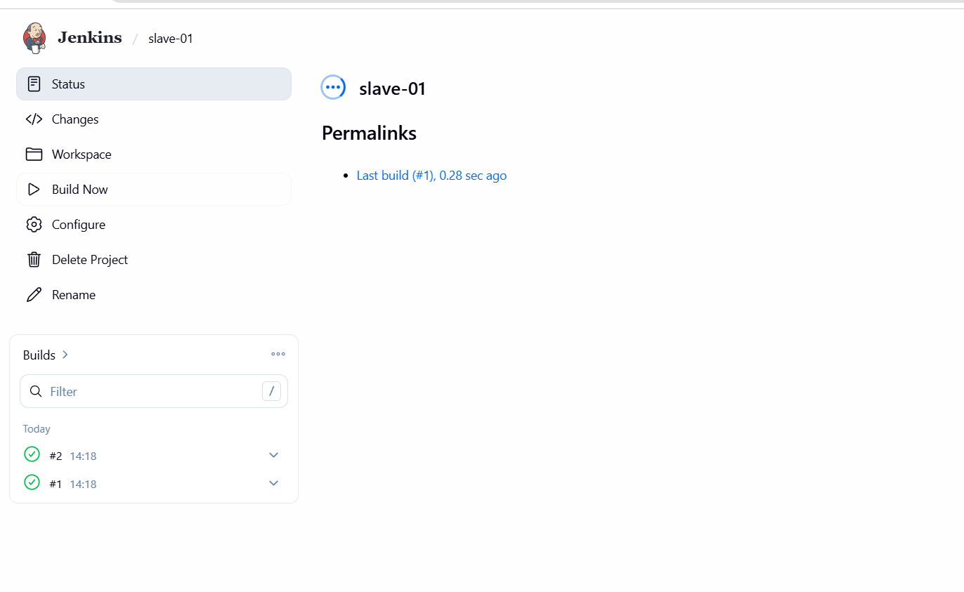
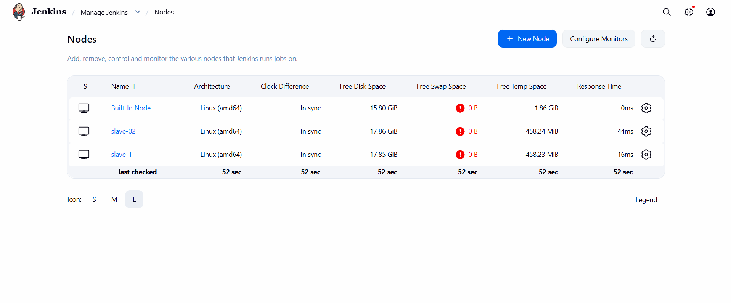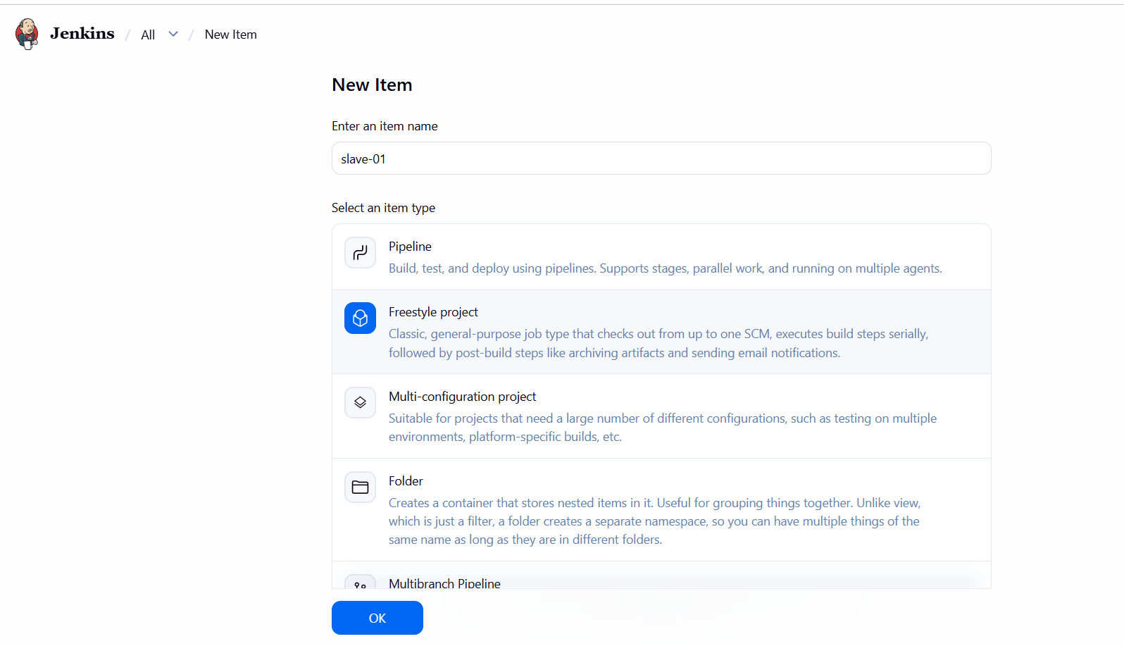

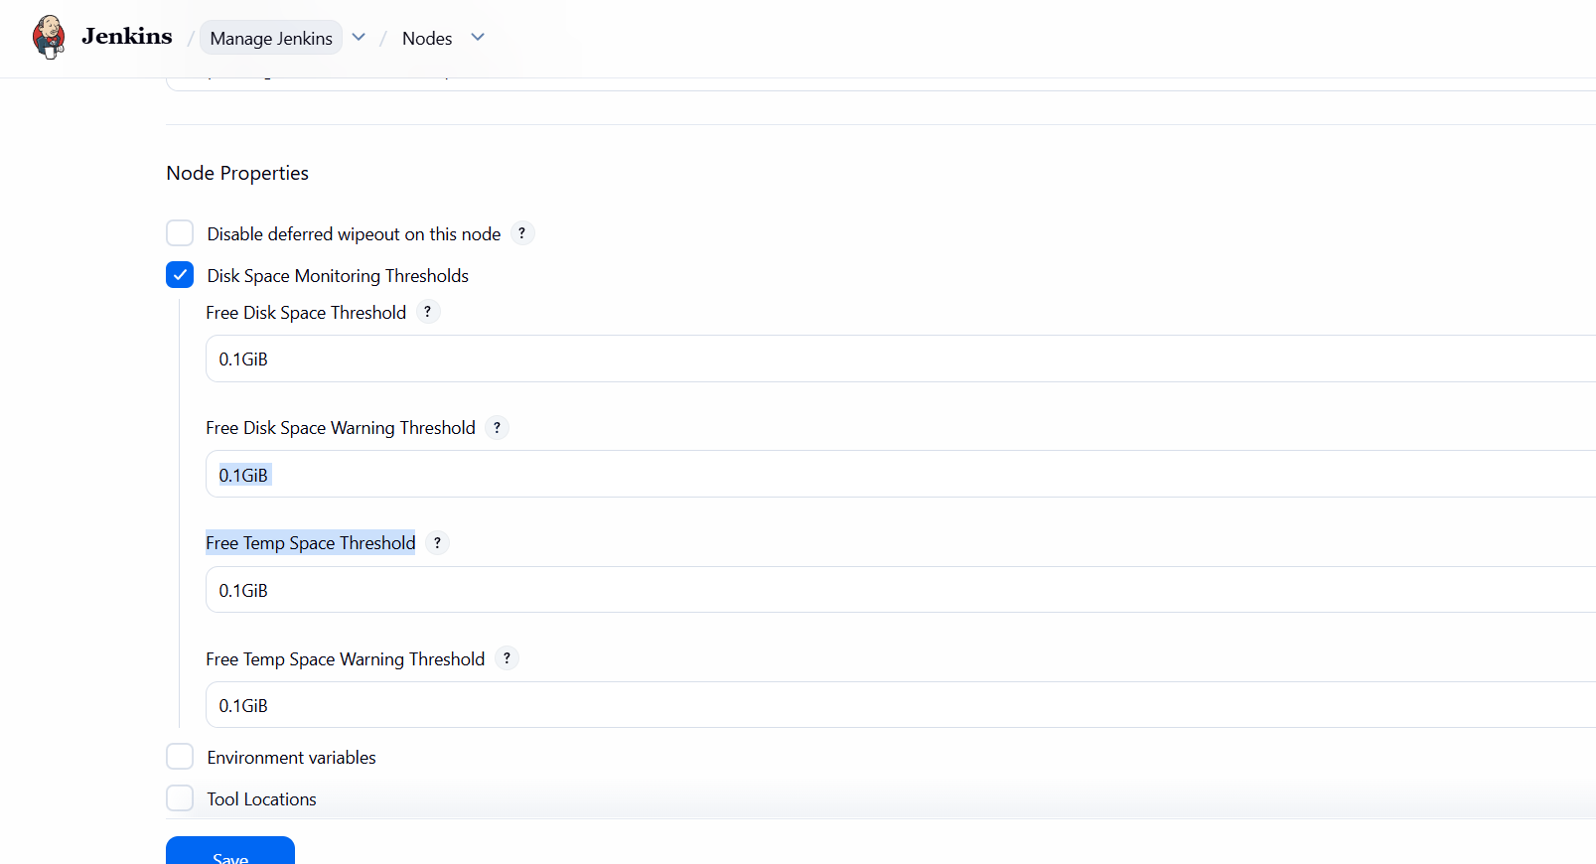

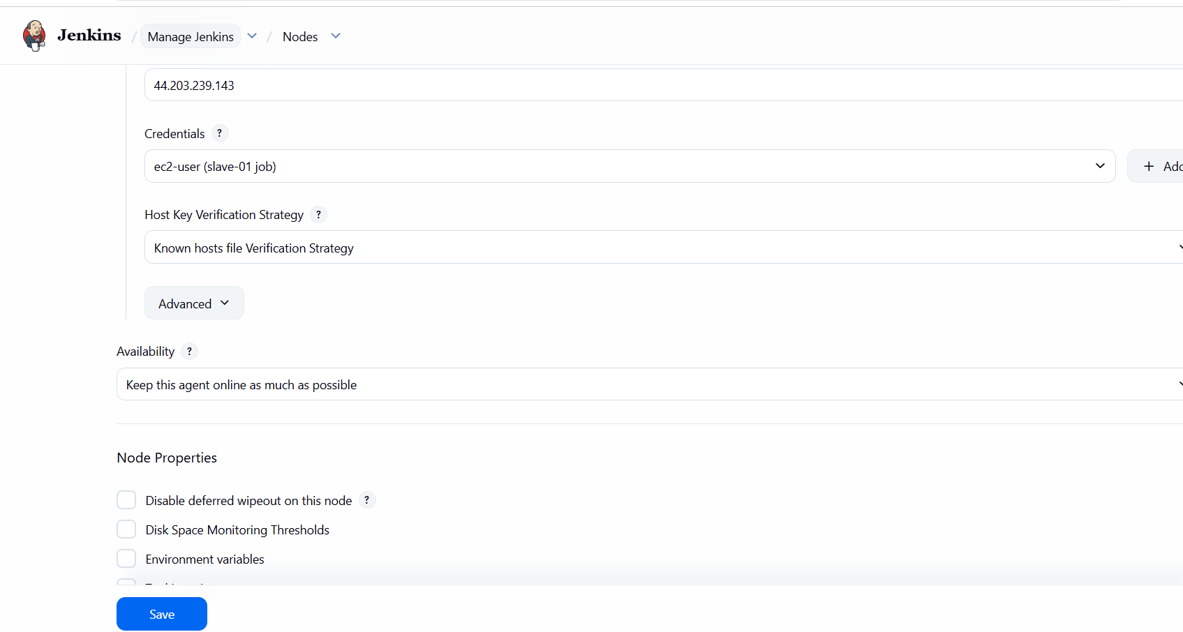

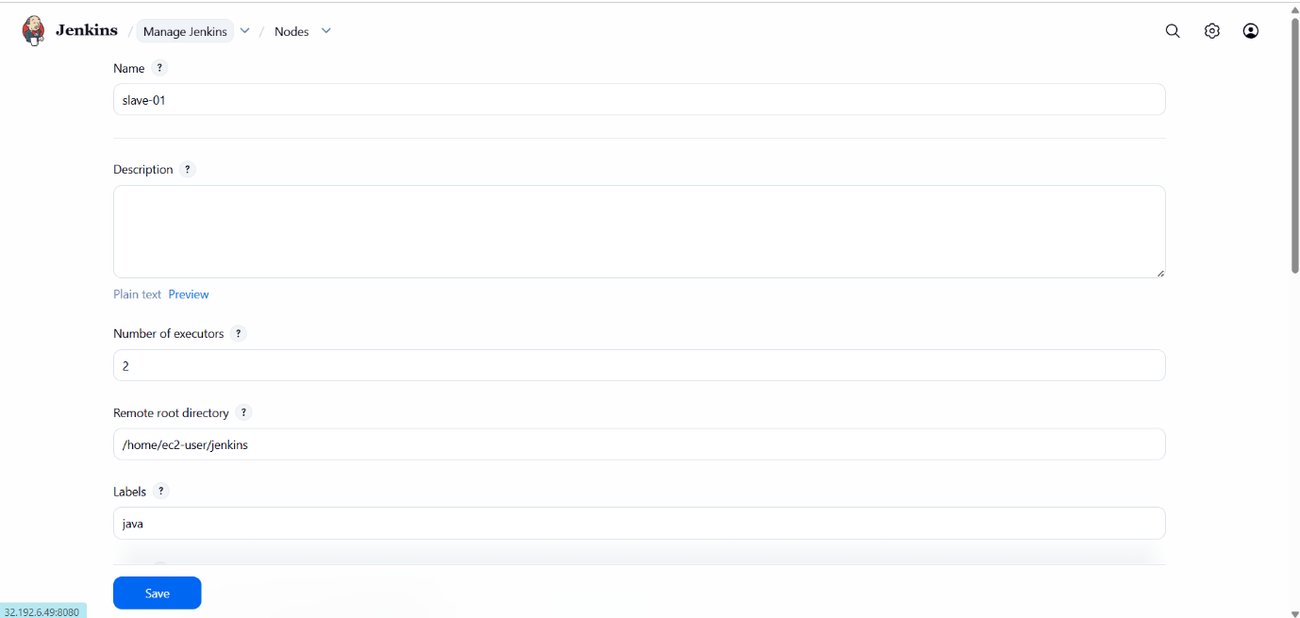
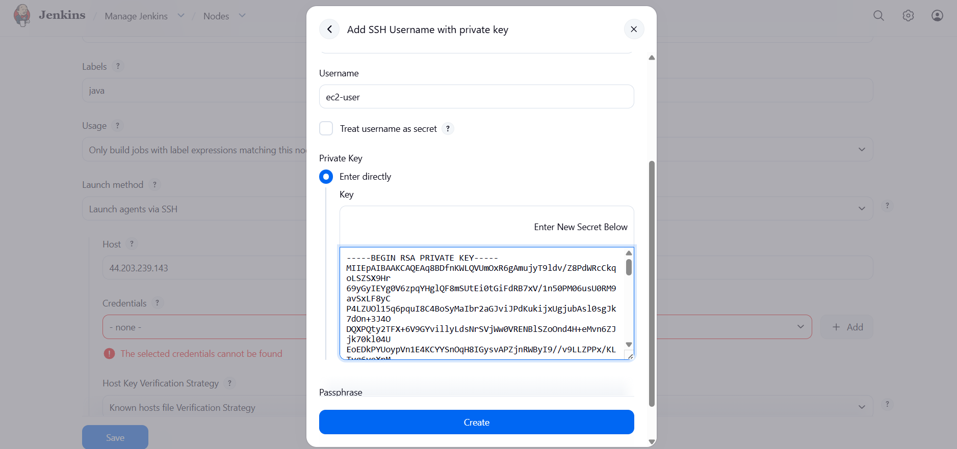



Jenkins Official Documentation
Recommended
- Pipeline:https://www.jenkins.io/doc/book/pipeline/
- Environment Variables:https://www.jenkins.io/doc/book/pipeline/jenkinsfile/#using-environment-variables
- Parameters:https://www.jenkins.io/doc/book/pipeline/syntax/#parameters
- Handling credentials in Pipeline:https://www.jenkins.io/doc/book/pipeline/jenkinsfile/#handling-credentials

